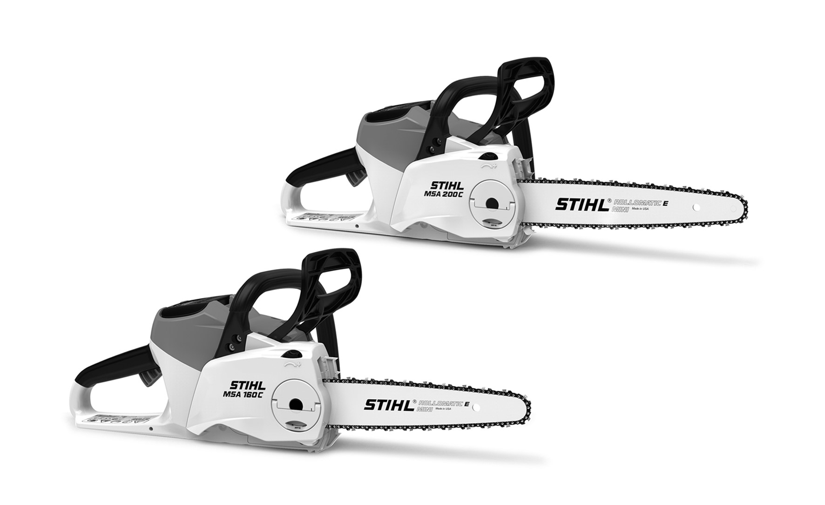
{
STIHL MSA 160 C, 200 C
Gebrauchsanleitung
Instruction Manual
Notice d’emploi
Manual de instrucciones
Istruzioni d’uso
Instruções de serviço
Handleiding
D Gebrauchsanleitung
1 - 43
G Instruction Manual
44 - 83
F Notice d’emploi
84 - 127
E Manual de instrucciones
128 - 170
I Istruzioni d’uso
171 - 212
P Instruções de serviço
213 - 253
n Handleiding
254 - 294

Contents
- Introduction . . . . . . . . . . . . . . . . . . . . . . . . . . . . . . . . . . . . . . . . 45
- Guide to Using this Manual. . . . . . . . . . . . . . . . . . . . . . . . . 45
  - Applicable Documentation. . . . . . . . . . . . . . . . . . . . . . . . . . 45
  - Warning Notices in Text . . . . . . . . . . . . . . . . . . . . . . . . . . . . 46
  - Symbols in Text . . . . . . . . . . . . . . . . . . . . . . . . . . . . . . . . . . . . 46
- Overview. . . . . . . . . . . . . . . . . . . . . . . . . . . . . . . . . . . . . . . . . . . 46
  - Chainsaw and Battery . . . . . . . . . . . . . . . . . . . . . . . . . . . . . . 46
  - Symbols . . . . . . . . . . . . . . . . . . . . . . . . . . . . . . . . . . . . . . . . . . . 47
- Safety Precautions . . . . . . . . . . . . . . . . . . . . . . . . . . . . . . . . . 48
  - Warning Signs . . . . . . . . . . . . . . . . . . . . . . . . . . . . . . . . . . . . . 48
  - Intended Use. . . . . . . . . . . . . . . . . . . . . . . . . . . . . . . . . . . . . . . 48 4.3 The Operator. . . . . . . . . . . . . . . . . . . . . . . . . . . . . . . . . . . . . . . 48
  - Clothing and Equipment . . . . . . . . . . . . . . . . . . . . . . . . . . . . 49
  - Work Area and Surroundings . . . . . . . . . . . . . . . . . . . . . . . 50
  - Safe Condition . . . . . . . . . . . . . . . . . . . . . . . . . . . . . . . . . . . . . 50
  - Working . . . . . . . . . . . . . . . . . . . . . . . . . . . . . . . . . . . . . . . . . . . . 52
  - Reactive Forces. . . . . . . . . . . . . . . . . . . . . . . . . . . . . . . . . . . . 54
  - Transporting . . . . . . . . . . . . . . . . . . . . . . . . . . . . . . . . . . . . . . . 55
  - Storing. . . . . . . . . . . . . . . . . . . . . . . . . . . . . . . . . . . . . . . . . . . . . 56
  - Cleaning, Maintenance and Repairs. . . . . . . . . . . . . . . . 56
- Preparing the Saw for Operation . . . . . . . . . . . . . . . . . . . 57
  - Preparing the Saw for Operation . . . . . . . . . . . . . . . . . . . 57
- Assembling the Saw. . . . . . . . . . . . . . . . . . . . . . . . . . . . . . . . 57
  - Mounting and Removing the Bar and Chain. . . . . . . . . 57
  - Tensioning the Saw Chain. . . . . . . . . . . . . . . . . . . . . . . . . . 59
  - Filling Up with Chain Oil . . . . . . . . . . . . . . . . . . . . . . . . . . . . 59
- Engaging and Disengaging the Chain Brake. . . . . . . . 60
  - Engaging the Chain Brake. . . . . . . . . . . . . . . . . . . . . . . . . . 60
  - Disengaging the Chain Brake. . . . . . . . . . . . . . . . . . . . . . . 61
- Removing and Fitting the Battery . . . . . . . . . . . . . . . . . . . 61
  - Fitting the Battery . . . . . . . . . . . . . . . . . . . . . . . . . . . . . . . . . . 61
  - Removing the Battery . . . . . . . . . . . . . . . . . . . . . . . . . . . . . . 61
English
Translation of Original Instruction
Manual
Printed on chlorine-free paper
Printing inks contain vegetabl
e oils, paper can be recycled.
© ANDREAS STIHL AG & Co. KG 2018
0458-701-9921-E. VA4.E18
.
0000007688_007
_GB
- Switching the Saw On/Off . . . . . . . . . . . . . . . . . . . . . . . . . . 61
  - Switching On. . . . . . . . . . . . . . . . . . . . . . . . . . . . . . . . . . . . . . . 61
  - Switching Off the Chain Saw . . . . . . . . . . . . . . . . . . . . . . . 62
- Testing the Chain Saw and Battery. . . . . . . . . . . . . . . . . 62
  - Checking the Chain Sprocket . . . . . . . . . . . . . . . . . . . . . . 62
  - Checking the Guide Bar. . . . . . . . . . . . . . . . . . . . . . . . . . . . 62
  - Checking the Saw Chain . . . . . . . . . . . . . . . . . . . . . . . . . . . 63
  - Testing the Chain Brake . . . . . . . . . . . . . . . . . . . . . . . . . . . 63
  - Checking the Controls . . . . . . . . . . . . . . . . . . . . . . . . . . . . . 63
  - Checking Chain Lubrication . . . . . . . . . . . . . . . . . . . . . . . . 64
  - Testing the Battery. . . . . . . . . . . . . . . . . . . . . . . . . . . . . . . . . 64
- Operating the Saw . . . . . . . . . . . . . . . . . . . . . . . . . . . . . . . . . 64
  - Holding and Controlling the Chainsaw. . . . . . . . . . . . . . 64
  - Sawing . . . . . . . . . . . . . . . . . . . . . . . . . . . . . . . . . . . . . . . . . . . . 64
  - Limbing. . . . . . . . . . . . . . . . . . . . . . . . . . . . . . . . . . . . . . . . . . . . 65
  - Felling . . . . . . . . . . . . . . . . . . . . . . . . . . . . . . . . . . . . . . . . . . . . . 65
- After Finishing Work . . . . . . . . . . . . . . . . . . . . . . . . . . . . . . . 70 12.1 After Finishing Work . . . . . . . . . . . . . . . . . . . . . . . . . . . . . . . 70
- Transporting . . . . . . . . . . . . . . . . . . . . . . . . . . . . . . . . . . . . . . . 70
  - Transporting the Chainsaw. . . . . . . . . . . . . . . . . . . . . . . . . 70
  - Transporting the Battery . . . . . . . . . . . . . . . . . . . . . . . . . . . 70
- Storing. . . . . . . . . . . . . . . . . . . . . . . . . . . . . . . . . . . . . . . . . . . . . 70
  - Storing the Chainsaw . . . . . . . . . . . . . . . . . . . . . . . . . . . . . . 70
  - Storing the Battery. . . . . . . . . . . . . . . . . . . . . . . . . . . . . . . . . 71
- Cleaning . . . . . . . . . . . . . . . . . . . . . . . . . . . . . . . . . . . . . . . . . . . 71
  - Cleaning the Saw . . . . . . . . . . . . . . . . . . . . . . . . . . . . . . . . . . 71
  - Cleaning the Bar and Chain. . . . . . . . . . . . . . . . . . . . . . . . 71
  - Cleaning the Battery . . . . . . . . . . . . . . . . . . . . . . . . . . . . . . . 71
- Maintenance . . . . . . . . . . . . . . . . . . . . . . . . . . . . . . . . . . . . . . . 71
  - Maintenance Intervals . . . . . . . . . . . . . . . . . . . . . . . . . . . . . 71
  - Deburring the Guide Bar . . . . . . . . . . . . . . . . . . . . . . . . . . . 72
  - Sharpening the Saw Chain. . . . . . . . . . . . . . . . . . . . . . . . . 72
- Repairing . . . . . . . . . . . . . . . . . . . . . . . . . . . . . . . . . . . . . . . . . . 73

This instruction manual is protected by copyright. All rights reserved, especially the rights to reproduce, translate and process with electronic systems.
{

1 Introduction
17.1 Repairing the Chainsaw and Battery . . . . . . . . . . . . . . . 73
- Troubleshooting. . . . . . . . . . . . . . . . . . . . . . . . . . . . . . . . . . . . 74
  - Troubleshooting Chainsaw or Battery . . . . . . . . . . . . . . 74
- Specifications . . . . . . . . . . . . . . . . . . . . . . . . . . . . . . . . . . . . . . 76
  - STIHL MSA 160 C, MSA 200 C Chainsaws. . . . . . . . . 76
  - Chain Sprockets and Chain Speeds . . . . . . . . . . . . . . . . 76
  - Minimum groove depth of guide bars . . . . . . . . . . . . . . . 76
  - STIHL AP battery . . . . . . . . . . . . . . . . . . . . . . . . . . . . . . . . . . 76
  - Noise and Vibration Data. . . . . . . . . . . . . . . . . . . . . . . . . . . 76
  - REACH . . . . . . . . . . . . . . . . . . . . . . . . . . . . . . . . . . . . . . . . . . . . 77
- Bar and Chain Combinations . . . . . . . . . . . . . . . . . . . . . . . 78
  - STIHL MSA 160 C, MSA 200 C Chainsaws. . . . . . . . . 78
- Spare Parts and Accessories. . . . . . . . . . . . . . . . . . . . . . . 79
  - Spare Parts and Accessories. . . . . . . . . . . . . . . . . . . . . . . 79
- Disposal . . . . . . . . . . . . . . . . . . . . . . . . . . . . . . . . . . . . . . . . . . . 79
  - Disposing of Chainsaw and Battery . . . . . . . . . . . . . . . . 79
- EC Declaration of Conformity. . . . . . . . . . . . . . . . . . . . . . . 79
  - STIHL MSA 160 C, MSA 200 C Chainsaws. . . . . . . . . 79
- General Power Tool Safety Warnings. . . . . . . . . . . . . . . 80
  - Introduction . . . . . . . . . . . . . . . . . . . . . . . . . . . . . . . . . . . . . . . . 80
  - Work area safety. . . . . . . . . . . . . . . . . . . . . . . . . . . . . . . . . . . 80
  - Electrical safety. . . . . . . . . . . . . . . . . . . . . . . . . . . . . . . . . . . . 80
  - Personal safety . . . . . . . . . . . . . . . . . . . . . . . . . . . . . . . . . . . . 80
  - Power tool use and care . . . . . . . . . . . . . . . . . . . . . . . . . . . 81
  - Battery tool use and care . . . . . . . . . . . . . . . . . . . . . . . . . . 81
  - Service . . . . . . . . . . . . . . . . . . . . . . . . . . . . . . . . . . . . . . . . . . . . 82
  - Chain saw safety warnings. . . . . . . . . . . . . . . . . . . . . . . . . 82
  - Causes and operator prevention of kickback:. . . . . . . 82
1 | Introduction
Dear Customer,
Thank you for choosing STIHL. We develop and manufacture our quality products to meet our customers’ requirements. The products are designed for reliability even under extreme conditions.
STIHL also stands for premium service quality. Our specialist dealers guarantee competent advice and instruction as well as comprehensive service support.
We thank you for your confidence in us and hope you will enjoy working with your STIHL product.

Dr. Nikolas Stihl
IMPORTANT: READ BEFORE USE AND KEEP IN A SAFE PLACE.
2 | Guide to Using this Manual

2.1 Applicable Documentation
Local safety regulations apply.
► Read, understand and save the following documents in addition to this instruction manual:
- User instructions for STIHL AR battery
- Instruction manual for AP belt bag with connecting cable– Safety notes and precautions for STIHL AP battery
- Instruction manual for STIHL AL 101, 300, 500 chargers
- Safety information for STIHL batteries and products with built-in batteries: www.stihl.com/safety-datasheets

3 Overview
3 | Overview

2.2 Warning Notices in Text
DANGER
This notice refers to risks which result in serious or fatal injury. | 3.1 | Chainsaw and Battery
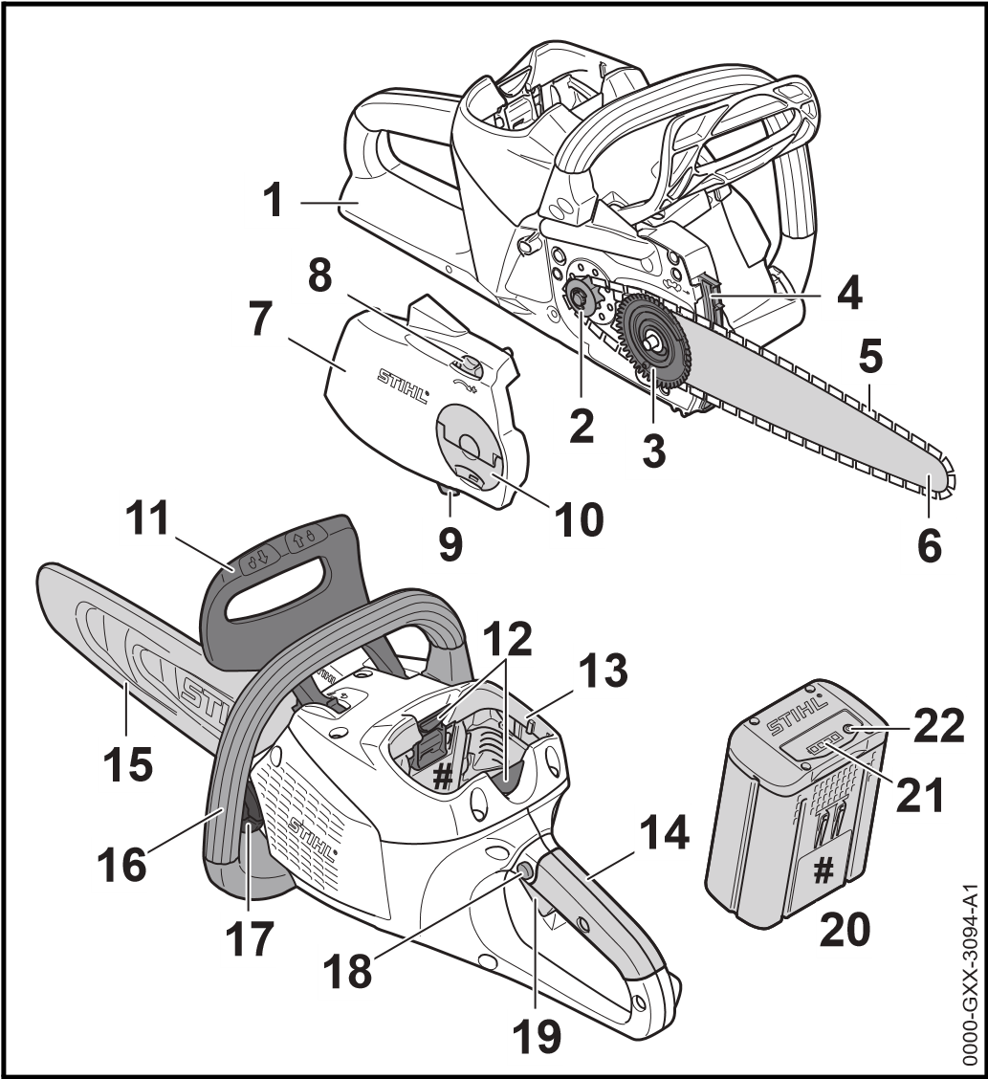
► Serious or fatal injuries can be avoided by taking the precautions mentioned.
WARNING
This notice refers to risks which can result in serious or fatal injury.
► Serious or fatal injuries can be avoided by taking the precautions mentioned.
NOTICE
This notice refers to risks which can result in damage to property.
► Damage to property can be avoided by taking the precautions mentioned.

2.3 Symbols in Text
This symbol refers to a chapter in this instruction manual.
- Rear Hand Guard
Protects operator’s right hand from contact with the chain if it comes off the bar or breaks.
- Chain Sprocket
Toothed wheel that drives the chain.
- Tensioning Gear
Moves guide bar to increase or reduce chain tension.
- Spiked Bumper
Toothed stop for holding saw steady against wood while cutting.

3 Overview
- Saw Chain Cuts the wood.
- Guide Bar
Supports and guides the saw chain.
- Chain Sprocket Cover
Covers the chain sprocket and secures the guide bar to the chainsaw.
- Adjusting Wheel
Permits precise adjustment of chain tension.
- Chain Catcher
Reduces risk of operator contact with the chain if it comes off the bar or breaks.
- Wingnut
Secures chain sprocket cover to chainsaw.
- Front Hand Guard
Helps protect operator’s left hand from contact with the saw chain, serves to engage the chain brake and activates the chain brake by inertia in certain kickback situations.
- Locking Lever
Secures the battery in the battery compartment.
- Battery Compartment Accommodates the battery.
- Control Handle
For operating, holding and controlling the chainsaw.
- Chain Scabbard
Helps protect user from contact with saw chain.
- Handlebar
For holding, controlling and carrying the chainsaw.
- Oil Tank Cap Closes the oil tank.
- Lockout Button Unlocks the trigger.
- Trigger
Switches the chainsaw on and off.
- Battery
Supplies power to the chainsaw.
- LEDs
Indicate battery’s state of charge and malfunctions.
- Button
Activates the LEDs on the battery.
# Rating Label with Serial Number

3.2 Symbols
Meanings of symbols that may be on the chainsaw and battery:
This symbol shows the direction of rotation of the chain.
Turn in this direction to tension the saw chain.
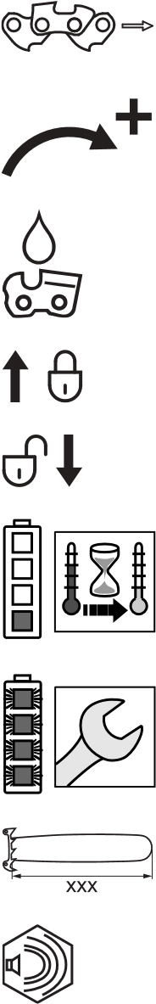
This symbol marks the chain oil tank.
The chain brake is engaged in this direction.
The chain brake is disengaged in this direction.
1 LED glows red. Battery too hot or too cold.
4 LEDs flash red. There is a malfunction in the battery.
Length of guide bar that may be used.
Guaranteed sound power level according to
LWA directive 2000/14/EC in dB(A) in order to make sound emissions of products comparable.

The data next to this symbol indicates the energy content of the battery according to the cell manufacturer’s specification. The energy content available during operation is lower.
Do not dispose of the product with your household waste.
4 | Safety Precautions

4.1 Warning Signs
Meanings of warning signs on the chainsaw and battery:
Observe safety notices and take the necessary precautions.
Read, understand and save the instruction manual.
Wear safety glasses and a hard hat.
Observe safety notices on kickback and take the necessary precautions.
Always remove the battery during work breaks, transport, storage, maintenance or repairs.
Protect battery from heat and fire.
Do not immerse battery in fluids.
Observe battery’s specified temperature range.

4.2 Intended Use
The STIHL MSA 160 C/MSA 200 C chainsaw is designed for cutting wood, limbing and felling small diameter trees and maintaining garden trees.
The chainsaw may be used in the rain.
The chainsaw is powered by a STIHL AP battery or a STIHL AR battery.

WARNING
￭ Batteries not explicitly approved for the chainsaw by STIHL may cause a fire or explosion. This can result in serious or fatal injuries and damage to property.
► Use the chainsaw with a STIHL AP battery or a STIHL AR battery.
￭ Using the chainsaw or the battery for purposes for which they were not intended may result in serious or fatal injuries and damage to property.
► Use the chainsaw as described in this instruction manual.
► Use the battery as described in this instruction manual or the instruction manual for the STIHL AR battery.

4.3 The Operator
WARNING
￭ Users without adequate training or instruction cannot recognize or assess the risks involved in using the chainsaw and battery. The user or other persons may sustain serious or fatal injuries.
► Read, understand and save the instruction manual.
► If the chainsaw or battery is passed on to another person: Always give them the instruction manual.
► Make sure the user meets the following requirements:
- The user must be rested.
- The user must be in good physical condition and mental health to operate and work with the chainsaw and battery. If the user’s physical, sensory or mental ability is restricted, he or she may work only under the supervision of or as instructed by a responsible person.
- The user must be legally recognized as an adult.
- The user has received instruction from a STIHL servicing dealer or other experienced user before working with the chainsaw for the first time.
- The user must not be under the influence of alcohol, medication or drugs.
► If the user is working with a chainsaw for the first time: Practice cutting logs on a sawhorse or other support.
► If you have any queries: Contact your STIHL servicing dealer for assistance.

4.4 Clothing and Equipment
WARNING
￭ Long hair can become entangled in the saw during operation. This can result in serious injuries.
► Tie up and confine long hair so that it cannot be entangled in the saw.
￭ Objects can be thrown through the air at high speed during operation. This can result in personal injury.
► Wear snug-fitting safety glasses. Suitable glasses that have been tested and labeled in accordance with EN 166 or national standards are available from retailers.
► STIHL recommends that you wear a face shield.
► Wear a long-sleeved, snug-fitting upper garment.
￭ Falling objects can cause head injuries.
► If there is a danger of falling objects during operation: Wear a safety hard hat.
￭ Dust can be whipped up during operation: Whipped up dust can damage the respiratory passages and cause allergic reactions.
► Wear a respirator.
￭ Inappropriate clothing can snag on wood, brush or the saw. Not wearing personal protective equipment may result in serious injury.
► Wear snug-fitting clothing.
► Do not wear a scarf or jewelry.
￭ The user can come into contact with the rotating saw chain during operation. This can result in serious injuries.
► Wear long trousers of the appropriate cut-retardant class.
￭ The user can be cut by the wood during operation. The user can come into contact with the saw chain during cleaning and maintenance work. This can result in personal injury.
► Wear work gloves made of durable material.
￭ Wearing unsuitable footwear may cause you to slip or stumble. Contact with the rotating saw chain can result in cuts. This can result in personal injury.
► Wear chainsaw boots with cut retardant inlays.

4.5 Work Area and Surroundings
4.5.1 Chainsaw WARNING
￭ Bystanders, children and animals are not aware of the dangers of the chainsaw or thrown objects. Innocent bystanders, children and animals may be seriously injured and damage to property may occur.
► Keep bystanders, children and animals away from the work area.
► Do not leave the chainsaw unattended.
► Make sure that children cannot play with the chainsaw.
￭ Electrical components of the chainsaw can produce sparks. Sparks may cause a fire or an explosion in an easily combustible or explosive environment. This can result in serious or fatal injuries and damage to property.
► Do not work in an easily combustible or explosive environment.
4.5.2 Battery

WARNING
￭ Bystanders, children and animals cannot recognize or assess the dangers of the battery. Innocent children, bystanders and animals may be seriously injured.
► Keep children, bystanders and animals away from the work area.
► Do not leave the battery unattended.
► Make sure that children cannot play with the battery.
￭ The battery is not protected against all ambient conditions. If the battery is exposed to certain ambient conditions, it may catch fire or explode. This can result in serious injuries and damage to property.
► Protect battery from heat and fire.
► Do not throw the battery into a fire.
► Use and store the battery at temperatures between -10°C and +50°C.
► Do not immerse battery in fluids.
► Keep battery away from metallic objects.
► Do not expose battery to high pressure.
► Do not expose battery to microwaves.
► Protect battery from chemicals and salts.

4.6 Safe Condition
4.6.1 Chainsaw
The chainsaw is in a safe condition if the following points are observed:
- The saw is not damaged.
- The saw is clean.
- The chain catcher is not damaged.
- Chain brake is operating properly.
- The controls function properly and have not been modified.
- Chain lubrication is operating properly.
- Wear marks on chain sprocket are not deeper than 0.5 mm.
- A combination of guide bar and saw chain recommended in this instruction manual is mounted.
- The guide bar and chain are properly mounted.
- The chain is properly tensioned.
- Only original STIHL accessories designed for this saw are fitted.
- Accessories are properly mounted.
- The oil tank is closed.

WARNING
￭ If components do not comply with safety requirements, they will no longer function properly and safety devices may be rendered inoperative. This can result in serious or fatal injuries.
► Work only with an undamaged chainsaw.
► If the saw is dirty: Clean the saw.
► Work only with an undamaged chain catcher.
► Never modify your chainsaw. Exception: Mounting a combination of guide bar and saw chain recommended in this instruction manual.
► If the controls do not function properly: Do not use your saw.
► Only fit original STIHL accessories designed for this saw model.
► Mount the guide bar and chain as described in this instruction manual.
► Mount accessories as described in this instruction manual or the instructions supplied with the accessory. ► Never insert objects in the saw’s openings.
► If you have any queries: Contact your STIHL servicing dealer for assistance.
4.6.2 Guide Bar
The guide bar is in a safe condition if the following points are observed:
- Guide bar is not damaged.
- Guide bar is not deformed.
- The minimum groove depth is maintained, @ 19.3.
- Bar rails are free from burrs.
- Bar groove is not pinched or splayed.

WARNING
￭ If the guide bar is not in a safe condition, it can no longer support and guide the saw chain properly. The rotating saw chain can jump off the guide bar. This can result in serious or fatal injuries.
► Work only with an undamaged guide bar.
► If the groove depth is less than the minimum depth: Mount a new guide bar.
► Deburr the guide bar every week.
► If you have any queries: Contact your STIHL servicing dealer.
4.6.3 Saw Chain
The saw chain is in a safe condition if the following conditions are fulfilled:
- The saw chain is undamaged.
- The saw chain has been sharpened as specified.
- The height of the cutter depth gauges is between the service marks.
- The length of the cutters is between the wear marks.

WARNING
￭ Parts that are not in a safe condition cannot function properly and safety devices can be disabled. People can be seriously injured or killed.
► Never use a damaged saw chain.
► Sharpen chain as specified.
► If in any doubt: Contact a STIHL servicing dealer.
4.6.4 Battery
The battery is in a safe condition if the following points are observed:
- Battery is undamaged.
- Battery is clean and dry.
- Battery functions properly and has not been modified.

WARNING
￭ A battery that is not in a safe condition cannot operate safely. This can result in serious injuries. ► Never work with a damaged battery.
► Never attempt to charge a damaged or defective battery.
► If the battery is dirty or wet: Clean the battery and allow it to dry.
► Never attempt to modify the battery.
► Never insert objects in the battery’s openings.
► Never bridge the battery's contacts with metallic objects (short circuit).
► Do not open the battery.
￭ Fluid may escape from a damaged battery. The fluid can cause irritation if it contacts the skin or eyes. ► Avoid contact with the fluid.
► In case of contact with the skin: Wash affected areas with plenty of water and soap.
► In case of contact with the eyes: Rinse eyes with plenty of water for at least 15 minutes and seek medical advice.
￭ A damaged or defective battery may smell unusual, emit smoke or burn. This can result in serious or fatal injuries and damage to property.
► If the battery smells unusual or emits smoke: Do not use the battery and keep it away from combustible substances.
► If the battery catches fire: Attempt to extinguish the battery with a fire extinguisher or water.

4.7 Working
4.7.1 Cutting WARNING
￭ Always work within calling distance of others in case help is needed.
► Make sure than persons outside the work area are within calling distance.
￭ The user cannot concentrate on the work in certain situations. The user can lose control of the saw, stumble or fall and be seriously injured. ► Work calmly and carefully.
► If light and visibility are poor: Do not use your saw.
► Operate the chainsaw alone.
► Do not work above shoulder height.
► Watch out for obstacles.
► Stand on the ground while working and keep a good balance. If it is necessary to work at heights: Use a lift bucket or a safe platform.
► If you begin to feel tired: Take a break.
￭ The rotating saw chain can cut the operator. This can result in serious injuries.
► Do not touch the rotating saw chain.
► If the saw chain is blocked by an object: Switch off the chainsaw, engage the chain brake and remove the battery. Then remove the object causing the blockage.
￭ The rotating chain becomes hot and expands. If the chain is not lubricated sufficiently and re-tensioned at regular intervals, it man come off the guide bar or break. This can result in serious injuries and damage to property. ► Use special chain oil.
► Check chain tension regularly during cutting work. If chain tension is insufficient: Tension the chain.
￭ If the behavior of the saw changes during operation or feels unusual, it may no longer be in a safe condition. This can result in serious injuries and damage to property.
► Stop work, remove the battery and contact your STIHL servicing dealer for assistance.
￭ Saw vibrations may occur during operation. ► Wear gloves.
► Take regular breaks.
► If signs of circulation problems occur: Seek medical advice.
￭ Sparks may occur if the rotating chain makes contact with a hard object. Sparks may cause a fire in an easily combustible location. This can result in serious or fatal injuries and damage to property. ► Do not work in an easily combustible location.
￭ Note that the saw chain continues to rotate for a short period after you release the trigger. The rotating saw chain can cut the user. This can result in serious injuries. ► Wait for the chain to come to a standstill.
￭ The guide bar can be pinched when cutting wood that is under tension. The user can lose control of the saw and be seriously injured.
► Make a relieving cut in the compression side (1) first, then perform bucking cut at the tension side (2).

DANGER
￭ Working near live electric cables can result in accidental contact with the chain and damage the cables. This can result in serious or fatal injuries.
► Do not work near live electric cables.
4.7.2 Limbing

WARNING
￭ If the underside of the felled tree is limbed first, it will no longer be supported on the ground by branches. The tree can move during cutting work. This can result in serious or fatal injuries.
► Cut through large limbs on the underside of the tree only after it has been bucked.
► Do not stand on the log while limbing it.
￭ A branch may fall to the ground during limbing. The user may trip, fall or be seriously injured.
► Limb from the base to the crown of the tree.
Felling
WARNING
4.7.3
0000-
0
GXX-1245-A
1
2
1
2

WARNING
￭ Inexperienced users cannot assess the dangers of felling a tree. This can result in serious or fatal injuries and damage to property.
► If you have any queries: Do not fell the tree yourself.
￭ A tree and branches can fall on bystanders or objects during the felling operation. This can result in serious or fatal injuries and damage to property.
► Determine direction of fall so that the area in which the tree falls is clear.
► Do not allow bystanders, children or animals within 2.5 tree lengths of the felling site.
► Remove broken or dead branches from the tree crown before felling.
► If broken or dead branches cannot be removed from the crown: Do not fell the tree.
► Observe tree crown and crowns of neighboring trees and keep clear of falling branches.
￭ When the tree falls the trunk can break or spring back in the direction of the user. This can result in serious or fatal injuries.
► Plan an escape path sideways behind the tree.
► Walk backwards along the escape path and observe the falling tree.
► Do not walk backwards down slopes.
￭ Obstacles in the work area and on the escape path can hinder the user. The user may trip and fall. This can result in serious or fatal injuries.
► Remove all obstacles from the work area and escape path.
￭ If you cut into or through the hinge, stabilizing strap or holding strap too soon, the intended direction of fall cannot be controlled or the tree can fall prematurely. This can result in serious or fatal injuries and damage to property.
► Do not cut into or through the hinge.
► Cut through the stabilizing strap or holding strap last.
► If the tree begins to fall too soon: Abandon the felling cut and retreat along the escape.
￭ Kickback can occur if the rotating chain in the upper quadrant of the bar nose makes contact with a hard felling wedge and is suddenly braked. This can result in serious or fatal injuries.
► Use aluminum or plastic felling wedges.
￭ If the tree does not fall all the way to the ground or gets caught on another tree, the operator cannot finish the operation in a controlled manner.
► Stop the felling operation and use a cable winch or suitable vehicle to pull the tree to the ground.

4.8 Reactive Forces
4.8.1 Kickback
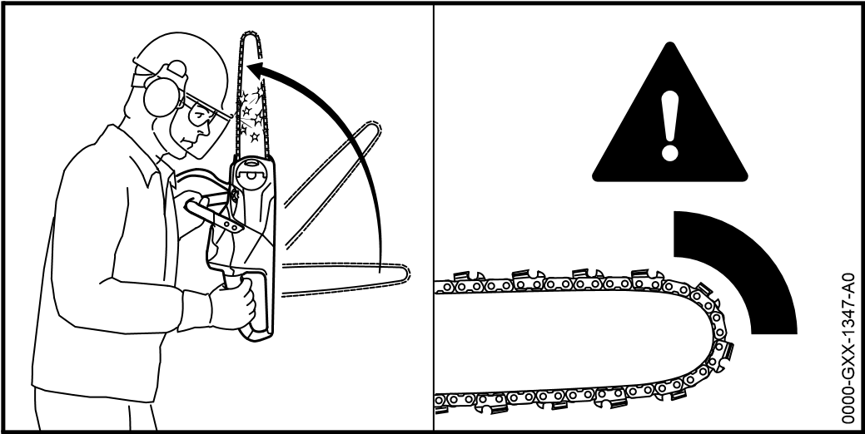
Kickback can be caused for the following reasons:
- The rotating saw chain in the upper quadrant of the bar nose makes contact with a hard object and is suddenly braked.
- The rotating saw chain is pinched at the bar nose.
The chain brake cannot prevent kickback.
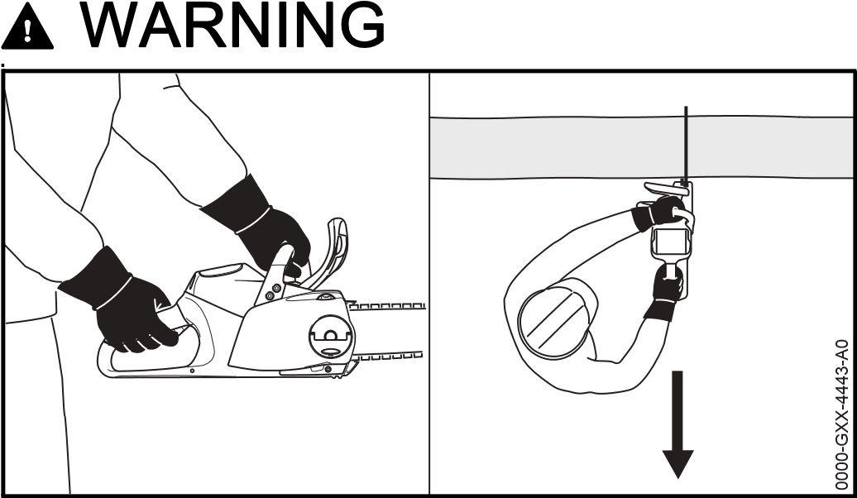
￭ If kickback occurs, the saw can be thrown up in the direction of the operator. The operator can lose control of the saw and be seriously or fatally injured. ► Hold the saw firmly with both hands.
► Always keep your body out of the plane of the cutting attachment.
►Use the working techniques described in this instruction
manual.
►Do not cut with the upper quadrant of the bar nose.
►Always cut with a properly sharpened and tensioned
saw chain.
►Use a reduced kickback saw chain.
►Use a guide bar with a narrow radius nose.
►Always cut with the chain running at full speed.
4.8.2
Pull-in
The saw is pushed back toward the operator when the top of
the bar is used for cutting.
WARNING
￭If the rotating chain makes contact with a hard object and
is suddenly pinched, the saw can be abruptly pushed back
toward the operator. The operator can lose control of the
saw and be seriously or fatally injured.
►Hold the saw firmly with both hands.
►Operate the saw as described in this instruction manual.
►Keep the guide bar straight in the cut.
►Always cut with the chain running at full speed.
4.9
Transporting
0000-
0
GXX-1348-A
0
0000-
GXX-1349-A
The saw is pulled away from the operator when the bottom of the bar is used for cutting.

WARNING
￭ If the rotating chain makes contact with a hard object and is suddenly pinched, the saw is abruptly jerked away from the operator. The operator can lose control of the saw and be seriously or fatally injured.
► Hold the saw firmly with both hands.
► Operate the saw as described in this instruction manual.
► Keep the guide bar straight in the cut.
► Apply the spiked bumper properly.
► Always cut with the chain running at full speed. 4.8.3 Pushback
4.9.1 Chainsaw WARNING
￭ The saw may turn over or shift during transport. This may result in personal injuries and damage to property.
► Remove the battery.
► Engage the chain brake.
► Fit the scabbard so that it completely covers the guide bar.
► Secure the chainsaw with lashing straps or a net to prevent it turning over and moving.
4.9.2 Battery

WARNING
￭ The battery is not protected against all ambient conditions. The battery may be damaged if it is exposed to certain ambient conditions and damage to property may occur.
► Never transport a damaged battery.
► Store the battery in non-conductive packaging.
￭ The battery may turn over or shift during transport. This may result in personal injuries and damage to property.
► Pack the battery in packaging in such a way that it cannot move.
► Secure the packaging so that it cannot move.

4.10 Storing
4.10.1 Chainsaw WARNING
￭ Children are not aware of and cannot assess the dangers of a chainsaw and can be seriously injured.
► Remove the battery.
► Engage the chain brake.
► Fit the scabbard so that it completely covers the guide bar.
► Store the saw out of the reach of children.
￭ Dampness can corrode the electrical contacts on the saw and metal components. This can damage the saw.
► Remove the battery.
► Store the saw in a clean and dry condition.
4.10.2 Battery

WARNING
￭ Children are not aware of and cannot assess the dangers of the battery and can be seriously injured. ► Store the battery out of the reach of children.
￭ The battery is not protected against all ambient conditions. The battery may be damaged if it is exposed to certain ambient conditions.
► Store the battery in a clean and dry condition.
► Store the battery in an enclosed location.
► Store the battery separately from the chain saw and charger.
► Store the battery in non-conductive packaging.
► Store the battery at temperatures between -10°C and +50°C.

4.11 Cleaning, Maintenance and Repairs
WARNING
￭ The saw may start unintentionally if the battery is left in place during cleaning, maintenance or repair operations. This can result in serious injuries and damage to property.

5 Preparing the Saw for Operation ► Remove the battery.
► Engage the chain brake.
￭ Aggressive cleaning agents, a water jet or pointed objects can damage the saw, guide bar, saw chain, battery and charger. If the saw, guide bar, saw chain or battery are not cleaned correctly, components may no longer function properly or safety devices may be rendered inoperative. This can result in serious injuries.
► Clean the saw, guide bar, saw chain and battery as described in this instruction manual.
￭ If the saw, guide bar, saw chain or battery are not properly serviced or repaired, components may no longer function properly or safety devices may be rendered inoperative. This can result in serious or fatal injuries.
► Do not attempt to service or repair the chainsaw or battery.
► If the chainsaw or the battery require servicing or repairs: Contact your STIHL servicing dealer for assistance.
► Service or repair the guide bar and chain as described in this instruction manual.
￭ The user can be cut by the sharp cutters while cleaning or servicing the saw chain. This can result in personal injury.
► Wear work gloves made of durable material.
5 | Preparing the Saw for Operation

5.1 Preparing the Saw for Operation
Perform the following steps before starting work:
► Make sure the following components are in a safe condition:
- Chain saw, @ 4.6.1.
- Guide bar, @ 4.6.2.
- Saw chain, @ 4.6.3.
- Battery, @ 4.6.4.
► Check the battery, @ 10.7.
► Recharge the battery fully as described in the instruction manual for the STIHL AL 101, 300, 500 chargers.
► Clean the saw, @ 15.1.
► Mount the bar and chain, @ 6.1.1.
► Tension the saw chain, @ 6.2.
► Fill up with chain oil, @ 6.3.
► Check the chain brake, @ 10.4.
► Check the controls, @ 10.5.
► Check chain lubrication, @ 10.6.
► If you cannot carry out this work: Do not use your chainsaw and contact your STIHL servicing dealer for assistance.
6 | Assembling the Saw

6.1 Mounting and Removing the Bar and Chain
6.1.1 Mounting the Bar and Chain
The bar and chain combinations that can be used with the chain sprocket are listed in the specifications, @ 20.1.
► Switch off the chainsaw, engage the chain brake and remove the battery.
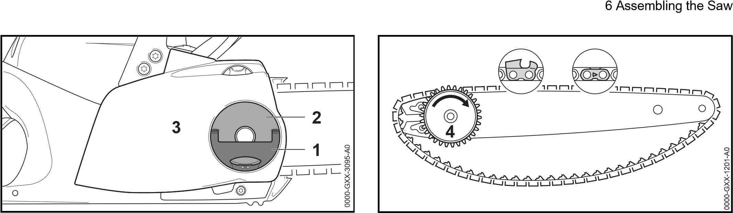
► Raise the grip (1) of the wingnut (2).
► Rotate the wingnut (2) counterclockwise until the chain sprocket cover (3) can be removed.
► Remove the tensioning gear (4).
► Take out the screw (5).
► Place the guide bar (6) on the tensioning gear (4) so that both pegs on the tensioning gear (4) engage the holes in the guide bar.
The guide bar (6) may be either way round. The logo on the guide bar may also be upside down.
► Insert and tighten down the screw (5) firmly.
► Fit the chain in the bar groove so that the arrows on the tie straps on top of the bar point in the direction of rotation.
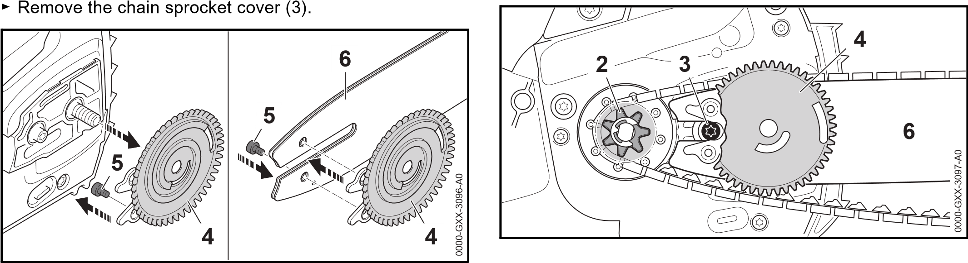
► Turn the tensioning gear (4) clockwise as far as stop.
► Fit the guide bar with tensioning gear and chain on the saw and check the following points:
- The tensioning gear (4) faces the user.
- Chain drive links are seated in teeth of chain sprocket
(2).
- Head of screw (3) locates in slot in guide bar (6).
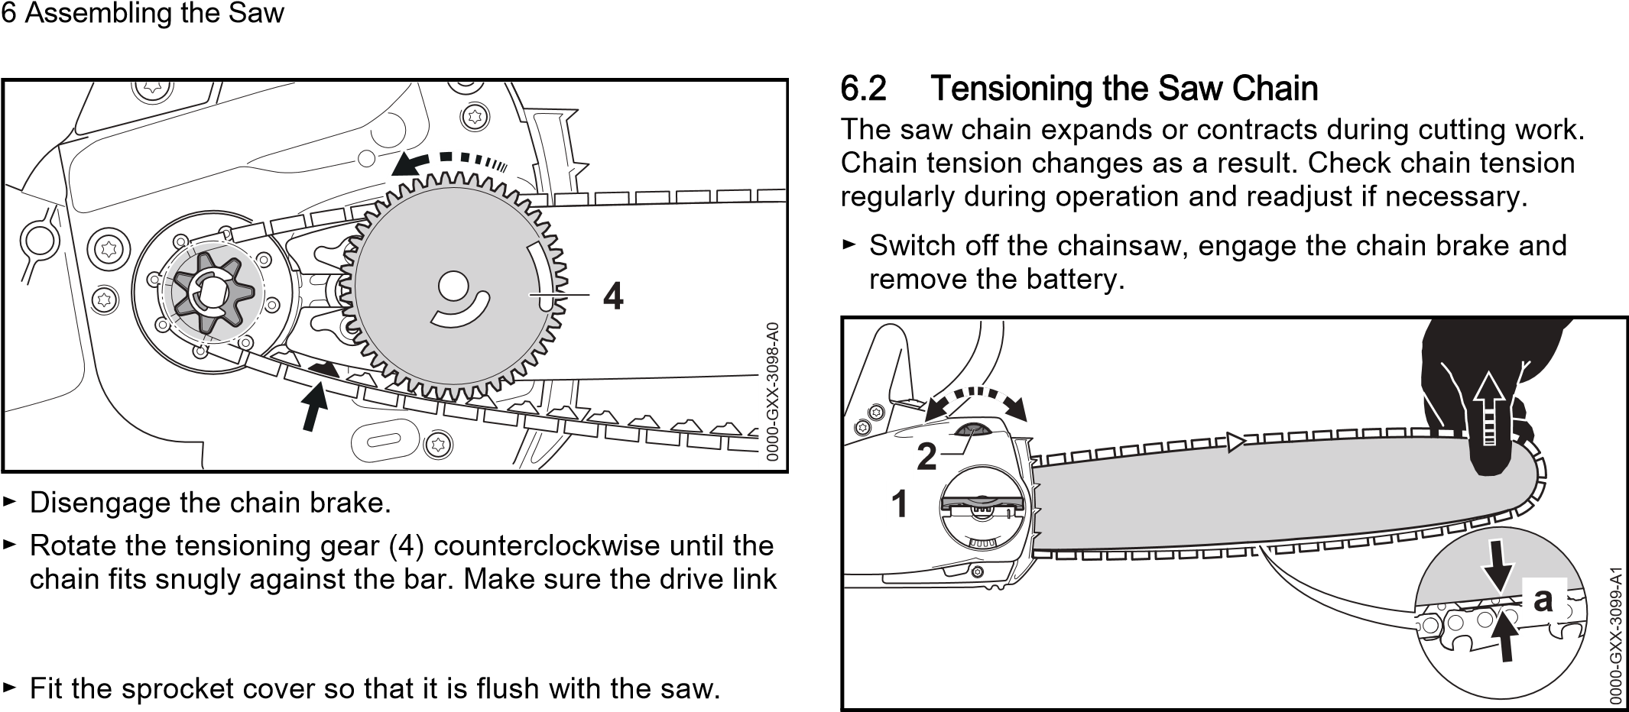
tangs engage the bar groove.
The guide bar and chain are positioned against the saw.
► If the sprocket cover is not flush with the saw: Turn the adjusting wheel slightly and refit the sprocket cover. The teeth of the adjusting wheel and tensioning gear must mesh.
► Rotate the wingnut clockwise until the chain sprocket cover is firmly seated.
► Fold down the grip of the wingnut.
6.1.2 Removing the Bar and Chain
► Switch off the chain saw, engage the chain brake and remove the battery.
► Raise the grip of the wingnut.
► Rotate the wingnut counterclockwise until the chain sprocket cover can be removed.
► Remove the sprocket cover.
► Turn the tensioning gear clockwise as far as stop. The chain is now slack.
► Remove the bar and chain.
► Take out the screw in the tensioning gear.
► Remove the tensioning gear.
► Raise the grip of the wingnut (1).
► Rotate the wingnut (1) two turns counterclockwise. The wingnut (1) is loose.
► Disengage the chain brake.
► Hold the bar nose up and turn the tensioning screw (2) clockwise or counterclockwise until the following points apply:
- Chain sag ‘a’ in the center of the bar is 1 - 2 mm.
- The chain can still be pulled easily along the bar with two fingers.
► While still holding the bar nose up, rotate the wingnut (1) clockwise until the chain sprocket cover is firmly seated.
► If chain sag ‘a’ in the center of the bar is not 1 - 2 mm: Readjust chain tension.
► Fold down the grip of the wingnut (1).

6.3 Filling Up with Chain Oil
Chain oil lubricates and cools the rotating chain.
► Switch off the chainsaw, engage the chain brake and remove the battery.
► Place your saw on a level surface so that the oil tank cap faces up.
► Use a damp cloth to clean the tank cap and the area around it.
GXX-2930-A
0
0000-
► Swing the grip on the oil tank cap to the vertical position.
► Turn the oil tank cap counterclockwise as far as stop.
► Remove the oil tank cap.
► Fill up with chain oil, taking care not to spill any oil and do not overfill the tank.
► If the grip on the oil tank cap has dropped into the closed position: Raise the grip until it is vertical.
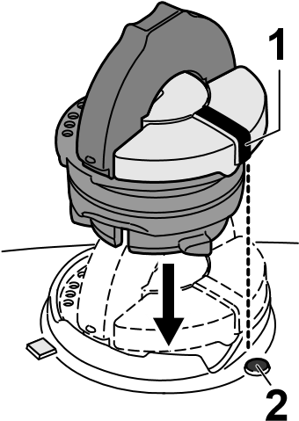 |  | 3  1 | 0000-  0  GXX-2931-A
► Place the cap in the filler opening so that mark (1) lines up with mark (2).
► Press the cap down and rotate it clockwise as far as stop.
The cap snaps into place. The mark (1) points to mark (3),
► Check to see if the oil tank cap can be pulled upwards and off.
7 Engaging and Disengaging the Chain Brake
► If the oil tank cap cannot be pulled upwards and off: Fold down the grip on the oil tank cap. The oil tank is closed.
If the oil tank cap can be pulled upwards and off, perform the following steps:
► Place the oil tank cap in the filler opening – in any position.
1
0
0000-
GXX-3135-A
2
► Press the cap down and rotate it clockwise as far as stop.
► Press the cap down and rotate it counterclockwise until mark (1) points to mark (2).
► Now try again to close the oil tank.
► If the oil tank still cannot be closed properly: Do not use the chainsaw and contact a STIHL dealer for assistance. The chainsaw is not in a safe condition.
7 | Engaging and Disengaging the Chain Brake

7.1 Engaging the Chain Brake
The saw is equipped with a chain brake.
The chain brake is activated by the inertia of the front hand guard if the kickback force is high enough or can be engaged by the operator.

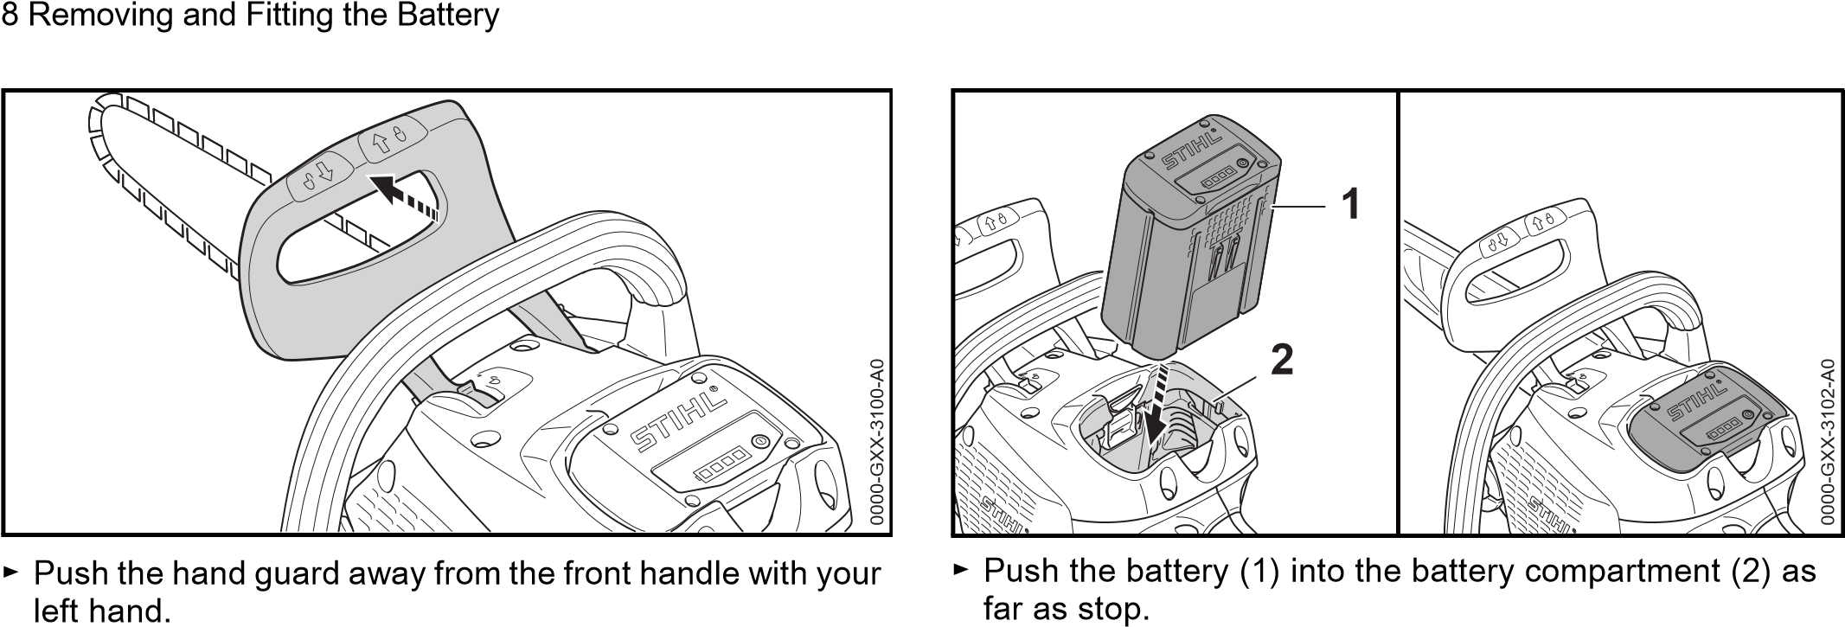
The hand guard engages with an audible click. The chain The battery (1) engages in position with a click. brake is engaged.
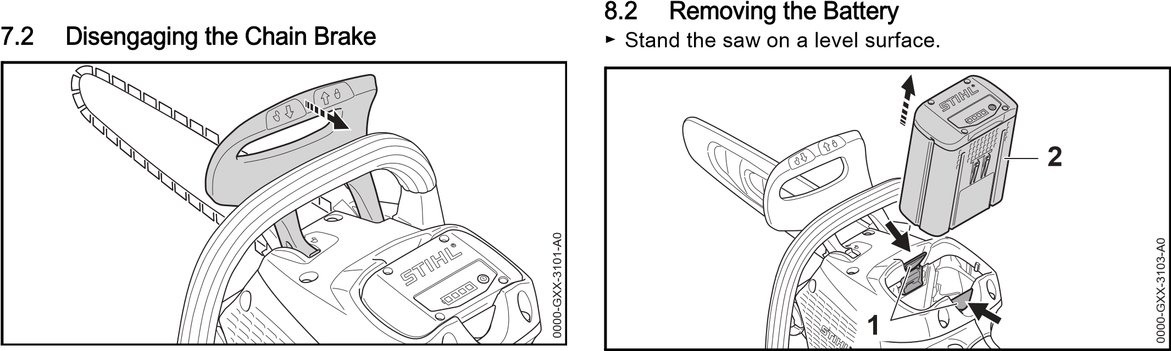
► Pull the hand guard toward the front handle with your left ► Press both locking levers (1). hand. The battery (2) is unlocked and can be removed.
The hand guard engages with an audible click. The chain brake is disengaged.
9 | Switching the Saw On/Off
8 | Removing and Fitting the Battery
9.1 Switching On
► Disengage the chain brake.
8.1 Fitting the Battery ► Engage the chain brake.

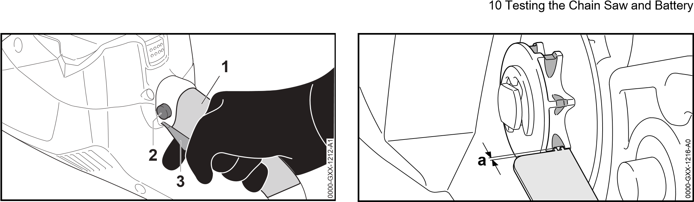
► Hold the saw with your right hand on the grip area (1) of the control handle – wrap your thumb around the control handle.
► Depress the lockout button (2) with your thumb and hold it there.
► Pull the trigger (3) with your index finger and hold it there. The motor is accelerated and the chain rotates.
► Hold the saw with your left hand on the front handle – wrap your thumb around the handlebar.

9.2 Switching Off the Chain Saw
► Release the trigger and lockout button. The saw chain stops running.
► If the chain continues to run: Engage the chain brake, remove the battery and contact a STIHL servicing dealer. The chain saw is defective.

10 Testing the Chain Saw and Battery

10.1 Checking the Chain Sprocket
► Switch off the chain saw, engage the chain brake and remove the battery.
► Disengage the chain brake.
► Remove the chain sprocket cover.
► Remove the bar and chain.
► Use a STIHL gauge to check the wear marks on the sprocket.
► If wear marks are deeper than a = 0.5 mm: Do not use your chain saw and contact your STIHL servicing dealer. The chain sprocket must be replaced.

10.2 Checking the Guide Bar
► Switch off the chain saw, engage the chain brake and remove the battery.
► Remove the chain and guide bar.
0000-
GXX-1217-A
0
► Measure depth of bar groove with scale on STIHL filing gauge.
► Install a new guide bar if one of the following points applies:
- Guide bar is damaged.
- Measured bar depth is less than specified minimum depth, @ 19.3.
10 Testing the Chain Saw and Battery
– Bar groove is pinched or splayed.
► If you have any queries: Contact your STIHL servicing dealer.

10.3 Checking the Saw Chain
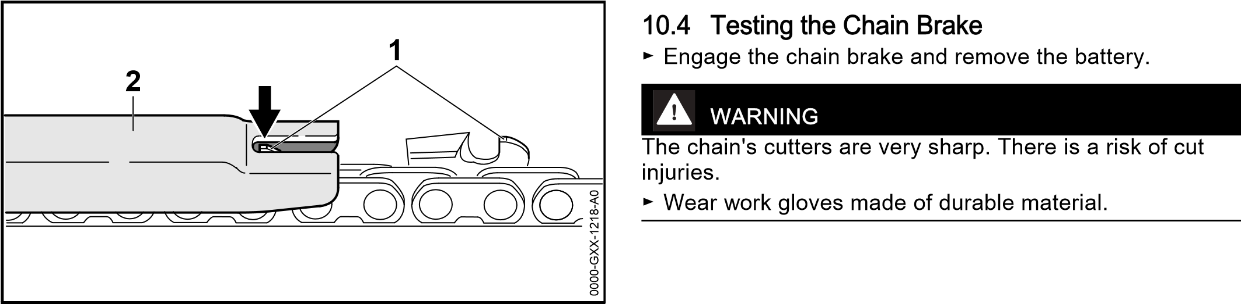
► Switch off the chainsaw, engage the chain brake and remove the battery.
► Use a STIHL filing gauge (2) to check the height of the depth gauges (1). The STIHL filing gauge must match the chain pitch.
► If a depth gauge (1) projects from the filing gauge (2): Lower the depth gauge (1), @ 16.3.
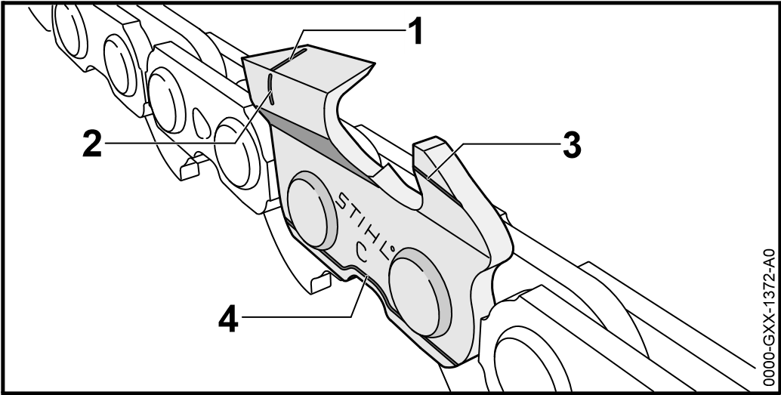
► Make sure the service marks (1 to 4) on the cutters are visible.
► If one of the service marks is not visible on a cutter: Do not use your chainsaw and contact your STIHL servicing dealer.
► Use a STIHL filing gauge to check that a filing angle of 30° has been maintained on all cutters. The STIHL filing gauge must match the chain pitch.
► If a filing angle of 30° has not been maintained: Resharpen the saw chain.
► If you have any queries: Contact your STIHL servicing dealer for assistance.
► Try to pull the chain along the guide bar by hand. If the chain cannot be pulled along the bar by hand, the chain brake is functioning.
► If the chain can be pulled along the bar by hand: Do not use your chain saw and contact your STIHL servicing dealer.
The chain brake is defective.

10.5 Checking the Controls
Lockout button and trigger lever
► Engage the chain brake and remove the battery.
► Attempt to pull the trigger lever without depressing the lockout button.
► If the trigger can be pulled: Contact your STIHL servicing dealer.
The lockout button is faulty.
► Depress the lockout button and hold it in that position.
► Pull the trigger and then let it go.
► If the trigger is stiff or does not spring back to its idle position: Do not use your chain saw and contact your STIHL servicing dealer.
The trigger has a malfunction.

Switching on
► Fit the battery.
► Disengage the chain brake.
► Depress the lockout button and hold it in that position.
► Pull the trigger and hold it there. The chain rotates.
► Release the trigger.
The chain stops rotating.
► If the chain continues to rotate: Engage the chain brake, remove the battery and contact your STIHL servicing dealer.
Your saw has a malfunction.

10.6 Checking Chain Lubrication
► Fit the battery.
► Disengage the chain brake.
► Hold the guide bar over a light surface.
► Switch on the saw.
Chain oil is thrown off the chain and is visible on the light surface. Chain lubrication is operating properly.
If no chain oil can be seen:
► Fill up with chain oil.
► Check chain lubrication again.
► If chain oil is still not visible on the light surface: Do not use your chain saw and contact your STIHL servicing dealer. Chain lubrication is defective.

10.7 Testing the Battery
► Press button on battery. The LEDs glow or flash.
► If the LEDs do not glow or flash: Do not use the battery and contact your STIHL servicing dealer.
There is a malfunction in the battery.

11 Operating the Saw

11.1 Holding and Controlling the Chainsaw
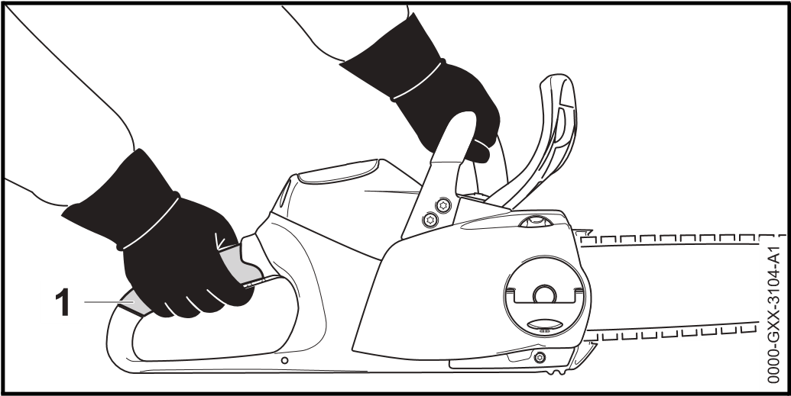
► Hold and control your saw with your left hand on the front handle and your right hand on the grip area (1) of the control handle. Wrap thumb of left hand around the front handle and thumb of right handle around the control handle.

11.2 Sawing
WARNING
If kickback occurs, the saw can be thrown up in the direction of the operator. This can result in serious or fatal injuries. ► Always cut with the chain running at full speed.
► Do not cut with the upper quadrant of the bar nose.

► Begin the cut with the chain running at full speed and keep the guide bar vertical.

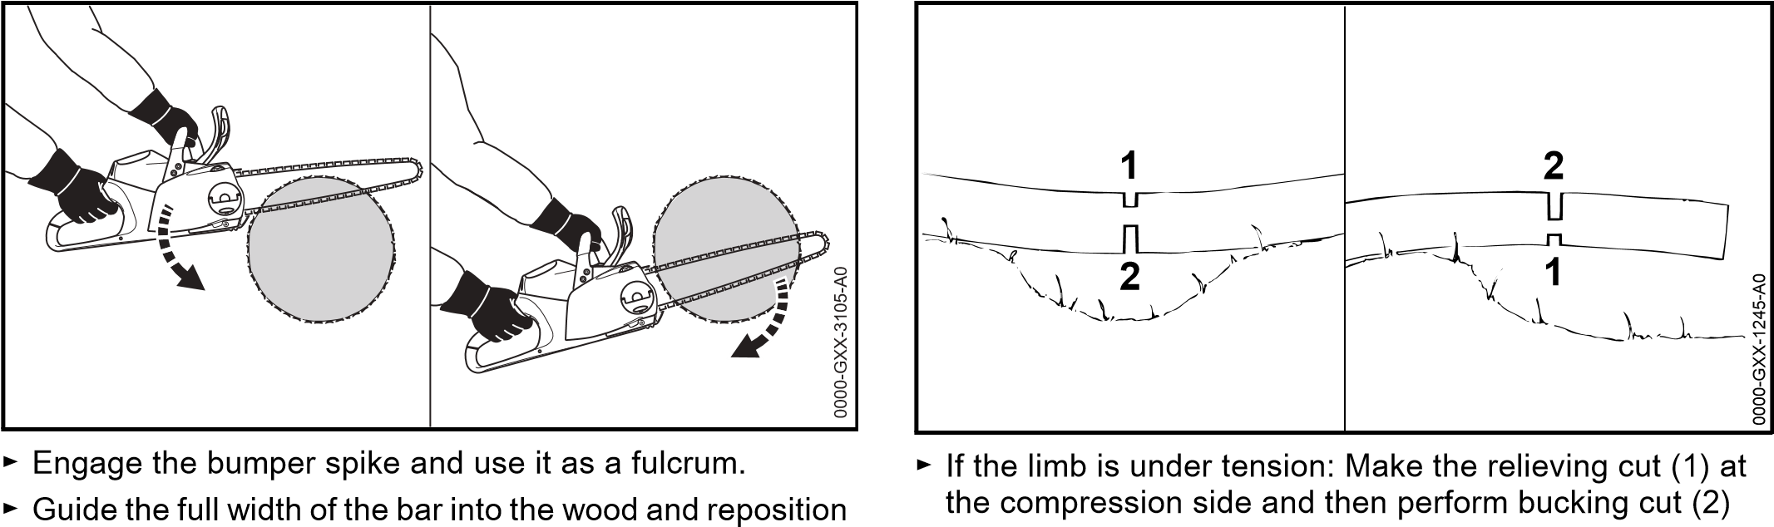
the bumper spike as required. from the tension side.
► Take the weight of the saw at the end of the cut.
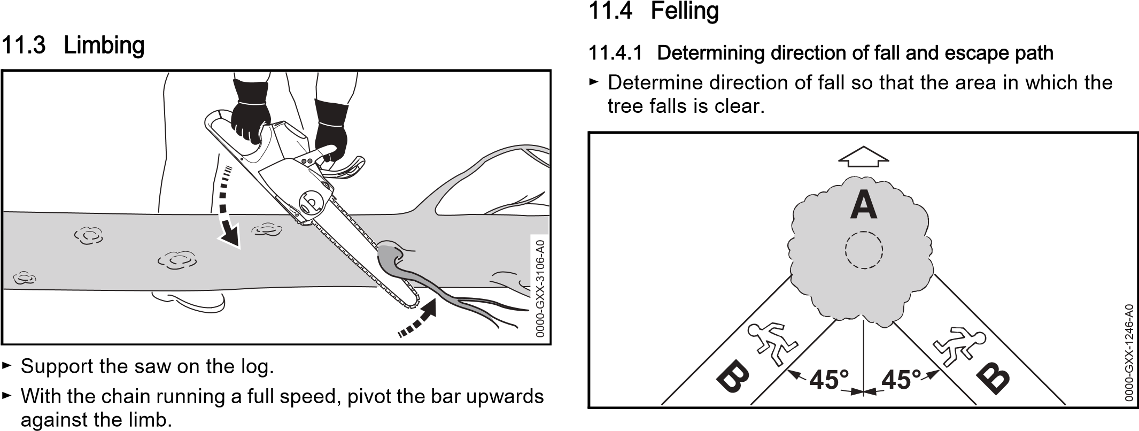
► Observe the following points when planning escape path ► Cut through the limb with the top of the bar. (B):
- Escape path (B) at an angle of 45° to direction of fall (A).
- No obstacles on the escape path (B).
- The top of the tree can be observed.
- If the escape path (B) is on a slope, it must be parallel to the slope.

11.4.2 Preparing work area at base of tree
► Remove obstacles from work area at tree base.
► Remove growth from tree base.
F Stabilizing strap
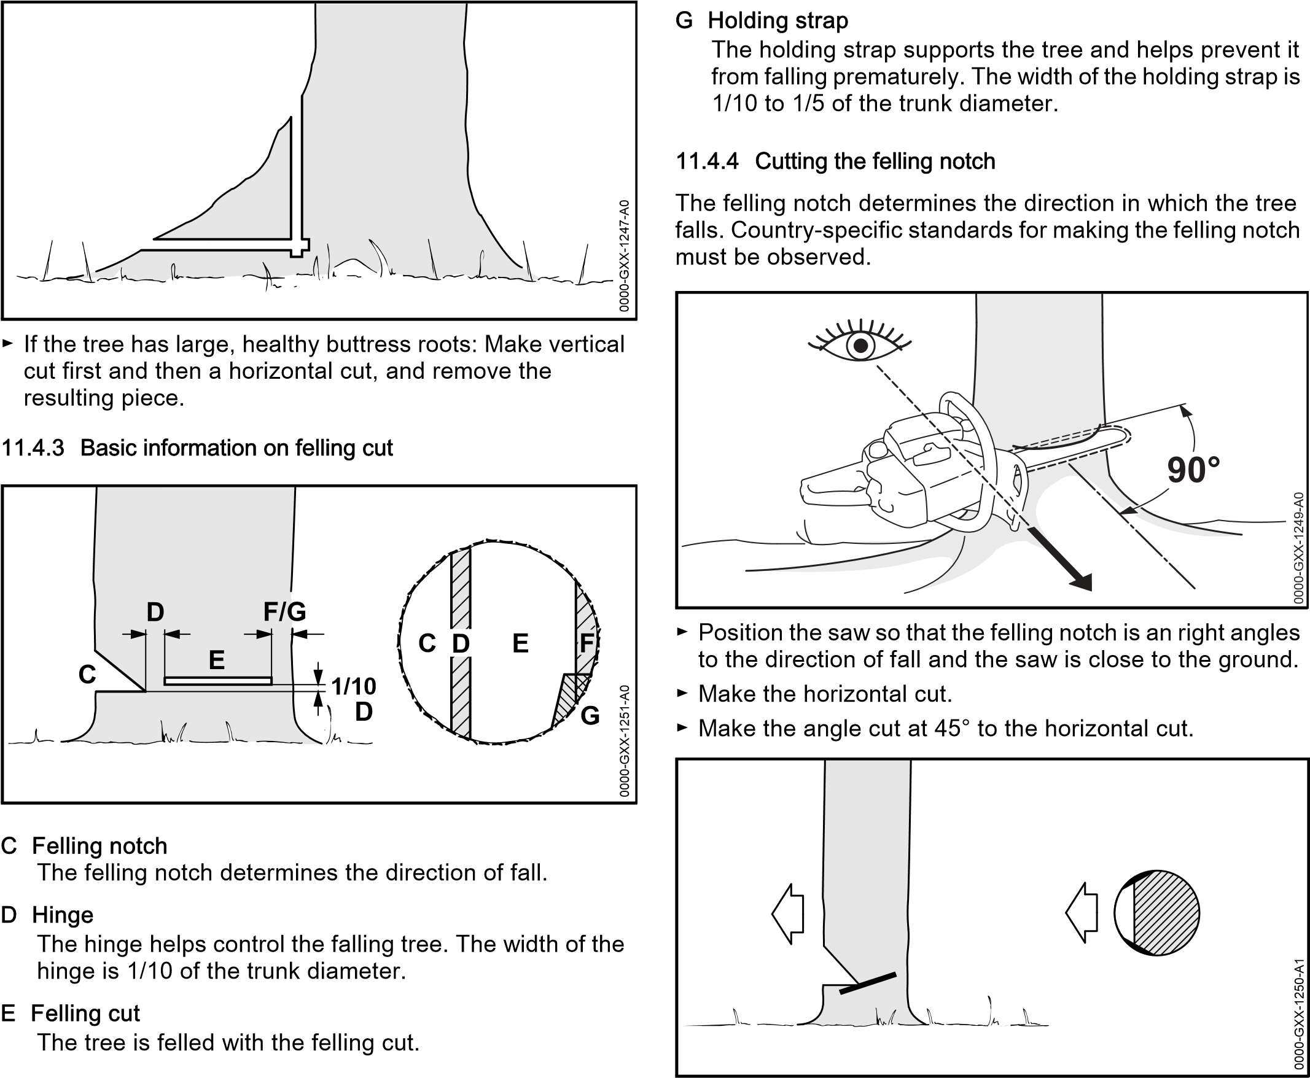
The stabilizing strap supports the tree and helps prevent it from falling prematurely. The width of the stabilizing strap is 1/10 to 1/5 of the trunk diameter.
► If the wood is sound and long-fibered: Observe the following points when making sapwood cuts:
- The cuts must be the same at both sides.
- The cuts must be at same height as bottom of felling notch.
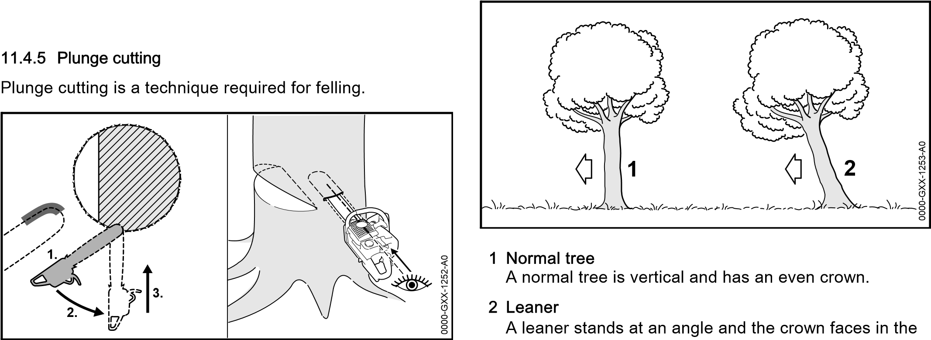
- The width of the cuts is 1/10 of the trunk diameter.
The trunk does not splinter when the tree falls.
► Begin cut with the lower portion of the guide bar nose – with chain running at full speed.
► Cut until depth of kerf is twice the width of the guide bar.
► Swing the saw into plunge-cutting position.
► Perform the plunge cut
11.4.6 Selecting the Appropriate Felling Cut
The choice of appropriate felling cut depends on the following conditions:
- The natural inclination of the tree
- The tree’s branch formation
- Damage to the tree
- The tree’s state of health
- If there is snow on the tree: the snow load
- The direction of slope
- Wind direction and speed– Nearby trees, if any
There are different features of these conditions. Only two features are described in this Instruction Manual.
direction of fall.
11.4.7 Felling normal, small diameter tree
A normal tree is felled with a felling cut and stabilizing strap. This felling cut must be performed if the tree diameter is less than the guide bar’s length.
► Shout a warning.
0
GXX-1254-A
0000-
1.
2.
► Plunge the guide bar into the felling cut until it is visible at the other side of the trunk, @ 11.4.5.
► Apply the spiked bumper behind the hinge and use it as a pivot.
► Enlarge felling cut in direction of hinge.
► Enlarge felling cut in direction of stabilizing strap.
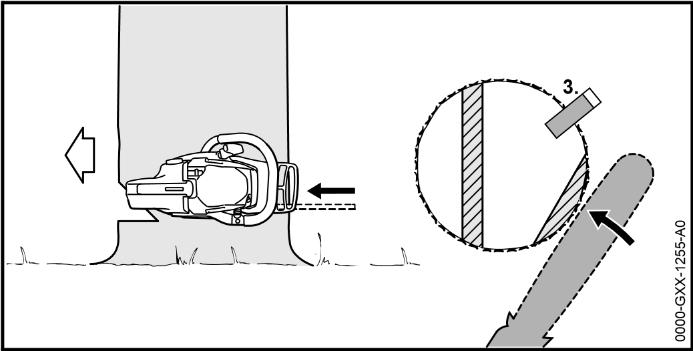
► Insert a felling wedge. The felling wedge must match the tree diameter and the width of the felling cut.
► Shout a warning.
► With outstretched arms, cut through the stabilizing strap horizontally from outside at the same level as the felling cut. The tree falls.
11.4.8 Felling normal, large diameter tree
A normal tree is felled with a felling cut and stabilizing strap. This felling cut must be performed if the tree diameter is greater than the guide bar’s length.
► Shout a warning.
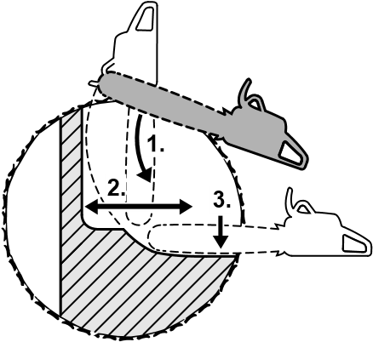 | 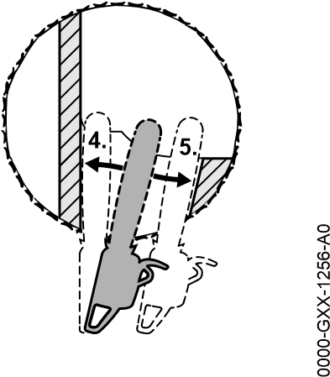
► Apply the spiked bumper at the same height as the felling cut and use it as a pivot.
► Hold the saw horizontally and swing it into the felling cut as far as possible.
► Enlarge felling cut in direction of hinge.
► Enlarge felling cut in direction of stabilizing strap.
► Move to the other side of the tree.
► Plunge the guide bar into the felling cut at the same height.
► Enlarge felling cut in direction of hinge.
► Enlarge felling cut in direction of stabilizing strap.
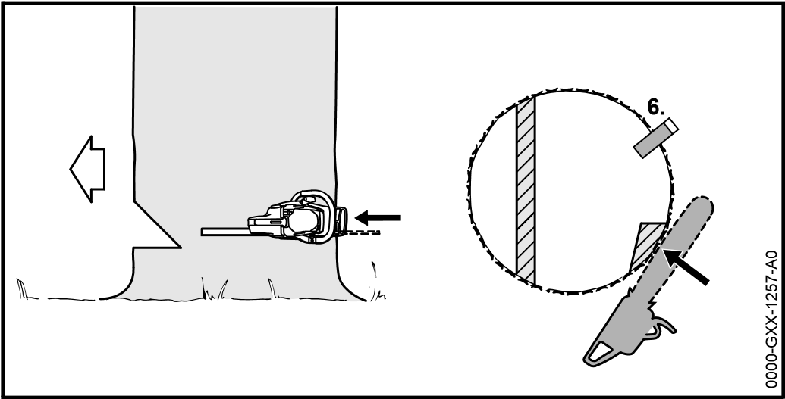
► Insert a felling wedge. The felling wedge must match the tree diameter and the width of the felling cut.
► Shout a warning.
► With outstretched arms, cut through the stabilizing strap horizontally from outside at the same level as the felling cut. The tree falls.
11.4.9 Felling a small diameter leaner
A leaner is felled with a felling cut and holding strap. This felling cut must be performed if the tree diameter is less than the guide bar’s length.
► Shout a warning.
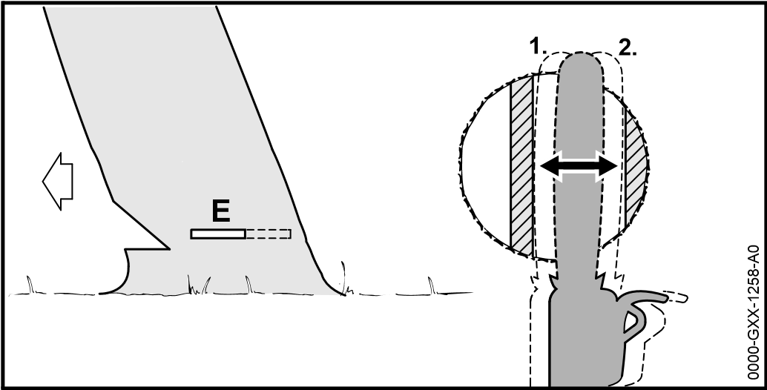
► Plunge the guide bar into the felling cut until it is visible at the other side of the trunk, @ 11.4.5.
► Enlarge felling cut in direction of hinge.
► Enlarge felling cut in direction of holding strap.
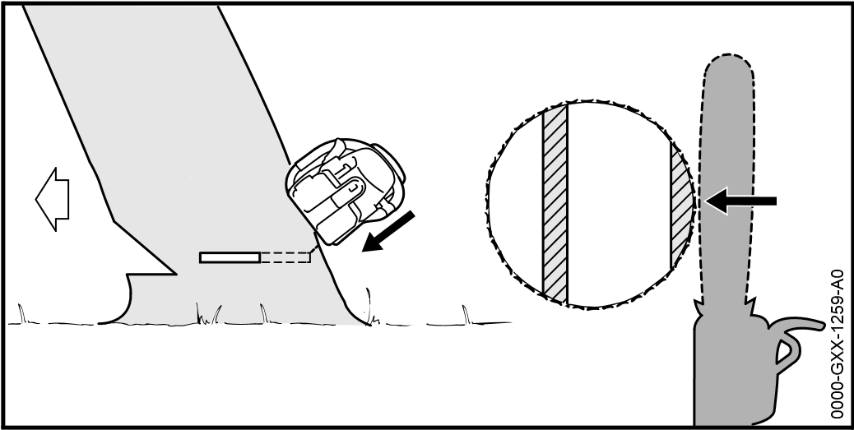
► Shout a warning.
► With arms outstretched, cut through the holding strap from outside at a downward angle. The tree falls.
11.4.10Felling a large diameter leaner
A leaner is felled with a felling cut and holding strap. This felling cut must be performed if the tree diameter is greater than the guide bar’s length.
► Shout a warning.
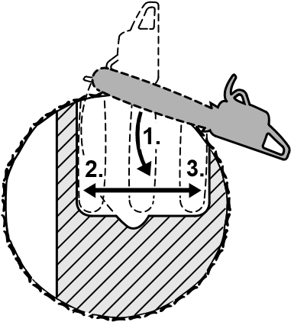 | 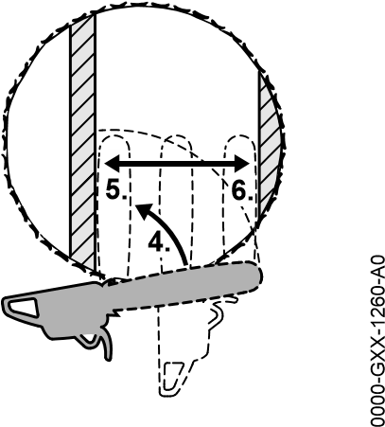
► Apply the spiked bumper behind the holding strap at the same height as the felling cut and use it as a pivot.
► Hold the saw horizontally and swing it into the felling cut as far as possible.
► Enlarge felling cut in direction of hinge.
► Enlarge felling cut in direction of holding strap.
► Move to the other side of the tree.
► Apply the spiked bumper behind the hinge at the same height as the felling cut and use it as a pivot.
► Hold the saw horizontally and swing it into the felling cut as far as possible.
► Enlarge felling cut in direction of hinge.
► Enlarge felling cut in direction of holding strap.

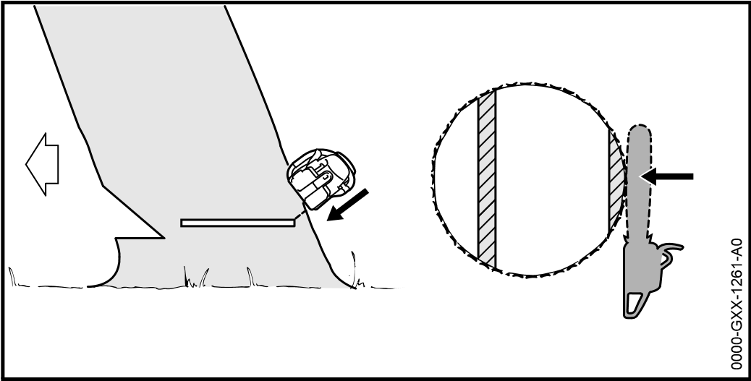
► Shout a warning.
► With arms outstretched, cut through the holding strap from outside at a downward angle. The tree falls.

12 After Finishing Work

12.1 After Finishing Work
► Switch off the chain saw, engage the chain brake and remove the battery.
► If the saw is wet: Allow the saw to dry.
► If the battery is wet: Allow the battery to dry.
► Clean the saw.
► Clean the bar and chain.
► Loosen the wingnut.
► Rotate the adjusting wheel two full turns counterclockwise.
The chain is now slack.
► Tighten down the wingnut.
► Fit the scabbard so that it completely covers the guide bar.
► Clean the battery.
12 After Finishing Work

13 Transporting

13.1 Transporting the Chainsaw
► Switch off the chainsaw, engage the chain brake and remove the battery.
► Fit the scabbard so that it completely covers the guide bar.
► Carry the saw by holding the front handle in your right hand with the guide bar pointing to the rear.
► Transporting the saw in a vehicle: Secure the saw to prevent turnover and movement.

13.2 Transporting the Battery
► Switch off the chain saw, engage the chain brake and remove the battery.
► Make sure the battery is in a safe condition.
► Observe the following points when packing the battery:
- The packaging must be non-conductive.
- Make sure the battery cannot shift inside the packaging.
► Secure the packaging so that it cannot move.
The battery is subject to the requirements for the transport of dangerous goods. The battery is classified as UN 3480 (lithium-ion batteries) and has been tested in accordance with UN Manual of Tests and Criteria, Part III, sub-section 38.3.
For transport regulations see www.stihl.com/safety-datasheets

14 Storing

14.1 Storing the Chainsaw
► Switch off the chainsaw, engage the chain brake and remove the battery.
► Fit the scabbard so that it completely covers the guide bar.
► Observe the following points when storing the saw:
15 Cleaning
- Saw is out of the reach of children.
- The saw is clean and dry.
► If you store the saw for more than 3 months: Remove the bar and chain.

14.2 Storing the Battery
STIHL recommends that you store the battery with a charge between 40% and 60% (2 LEDs glow green).
► Observe the following points when storing the battery:
- Battery is out of the reach of children.
- Battery is clean and dry.
- Battery is in an enclosed space.
- Store the battery separately from the saw and charger.
- Battery is in non-conductive packaging.
- Battery is in a temperature range between -10°C and +50°C.

15 Cleaning

15.1 Cleaning the Saw
► Switch off the chain saw, engage the chain brake and remove the battery.
► Clean the chain saw with a damp cloth or STIHL resin solvent.
► Remove the chain sprocket cover.
► Clean the area around the sprocket with a damp cloth or STIHL resin solvent.
► Remove foreign matter from the battery compartment and clean the battery compartment with a damp cloth.
► Clean electrical contacts in the battery compartment with a soft brush.
► Fit the chain sprocket cover.

15.2 Cleaning the Bar and Chain
► Switch off the chainsaw, engage the chain brake and remove the battery.
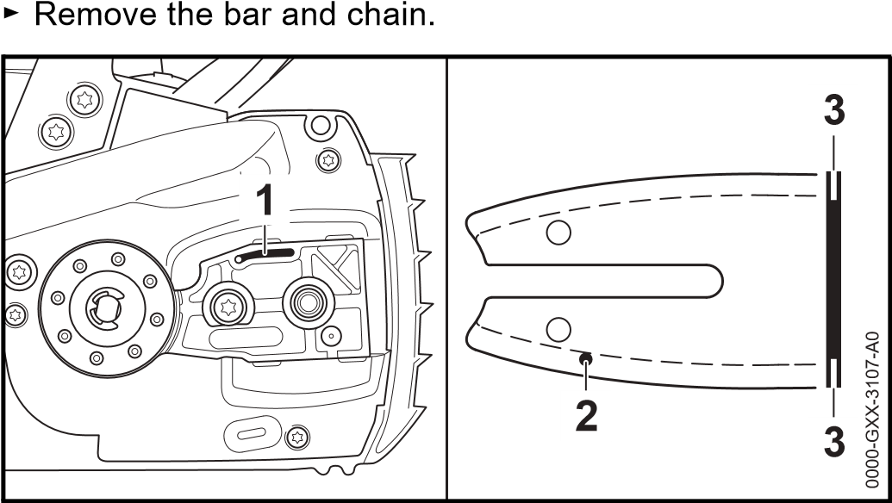
► Clean the oil port (1), oil inlet hole (2) and bar groove (3) with a soft brush or STIHL resin solvent.
► Clean the saw chain with a soft brush or STIHL resin solvent.
► Mount the bar and chain.
15.3 Cleaning the Battery
► Clean the battery with a damp cloth.

16 Maintenance

16.1 Maintenance Intervals
The maintenance intervals are dependent on the environmental and operating conditions. STIHL recommends the following maintenance intervals:
Chain brake
► Have the chain brake serviced by a STIHL servicing dealer at the following intervals: – Full-time usage: every 3 months
- Part-time usage: every 6 months
- Occasional usage: every 12 months
16 Maintenance
Weekly:
► Check the chain sprocket.
► Check and deburr the guide bar.
► Check and sharpen the saw chain.
Monthly:
► Have oil tank cleaned by a STIHL servicing dealer.

16.2 Deburring the Guide Bar
A burr can build up on the outer edge of the guide bar.
► Remove burr with a flat file or a STIHL guide bar dressing tool.
► If you have any queries: Contact your STIHL servicing dealer.

16.3 Sharpening the Saw Chain
Correctly sharpening saw chains requires a lot of practice.
STIHL files, STIHL filing aids, STIHL sharpeners and the brochure “Sharpening STIHL Saw Chains” help you achieve the right results. To obtain the brochure visit http:// www.stihl.com/sharpening-brochure.
STIHL recommends you have saw chains resharpened by a STIHL servicing dealer.
WARNING
The chain's cutters are very sharp. There is a risk of cut injuries.
► Wear work gloves made of durable material.

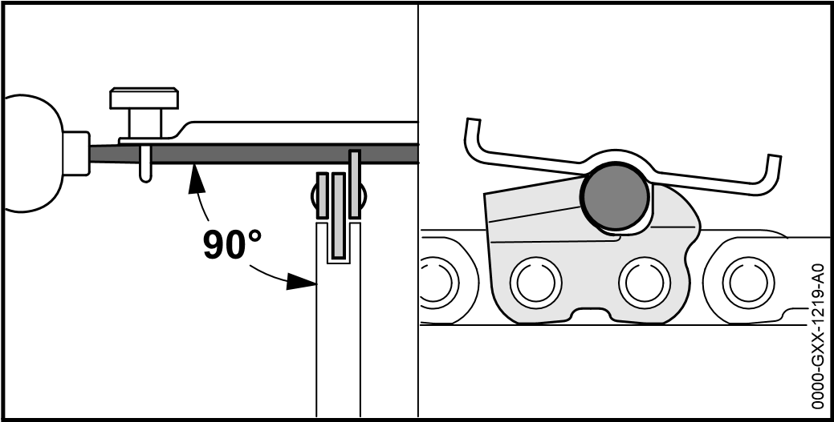
► File each cutter with a round file so that the following points are observed:
- Round file matches the chain pitch.
- File from the inside to the outside of the cutter.
- Hold the file at right angle to the guide bar.
- Maintain a filing angle of 30°.
GXX-1220-A
1
0000-
► File down the depth gauges with a flat file so that they are level with the STIHL filing gauge and parallel to the service mark. The STIHL filing gauge must match the chain pitch.
► If you have any queries: Contact your STIHL servicing dealer for assistance.
17 Repairing

17 Repairing

17.1 Repairing the Chainsaw and Battery
The chainsaw, guide bar, saw chain and battery cannot be repaired by the user.
► If the saw, guide bar or saw chain is damaged: Do not use your saw, guide bar or saw chain, and contact your STIHL servicing dealer for assistance.
► If the battery has a malfunction or is damaged: Replace the battery.

18 Troubleshooting

18 Troubleshooting

18.1 Troubleshooting Chainsaw or Battery
Condition | LEDs on Battery | Cause | Remedy
Saw does not start when switched on. | 1 LED flashes green | Battery has low charge. | ► Recharge the battery fully as described in the instruction manual for the STIHL AL 101, 300, 500 chargers.
 | 1 LED glows red. | Battery too hot or too cold. | ► Engage the chain brake and remove the battery.  ► Allow battery to cool down / warm up.
 | 3 LEDs flash red. | Malfunction in saw. | ► Engage the chain brake and remove the battery.  ► Clean contacts in battery compartment.  ► Fit the battery.  ► Disengage the chain brake.  ► Switch on the saw.  ► If 3 LEDs continue to flash red: Do not use your chainsaw and contact your STIHL servicing dealer for assistance.
 | 3 LEDs glow red | Chainsaw is too hot. | ► Engage the chain brake and remove the battery.  ► Allow chainsaw to cool down
 | 4 LEDs flash red. | There is a malfunction in the battery. | ► Engage the chain brake, remove and refit the battery.  ► Disengage the chain brake.  ► Switch on the saw.  ► If 4 LEDs continue to flash red: Do not use the battery and contact your STIHL dealer for assistance.
 |  | No electrical contact between the chainsaw and battery. | ► Engage the chain brake, remove and refit the battery.
 |  | Saw or battery damp | ► Allow saw or battery to dry
Saw cuts out during operation | 3 LEDs glow red | Chainsaw is too hot. | ► Remove the battery.  ► Allow chainsaw to cool down
18 Troubleshooting
Condition | LEDs on Battery | Cause | Remedy
 |  | There is a electrical malfunction. | ► Remove battery and insert it again.  ► Switch on the saw.
Chainsaw runtime is too short. |  | Battery not fully charged. | ► Recharge the battery fully as described in the instruction manual for the STIHL AL 101, 300, 500 chargers.
 |  | Normal battery life has been exceeded. | ► Replace the battery.

19 Specifications

19.1 STIHL MSA 160 C, MSA 200 C Chainsaws
MSA 160 C
- Approved batteries:
- STIHL AP– STIHL AR
- Weight without battery, guide bar and saw chain 2.7 kg
- Max. oil tank capacity: 210 cc (0.21 l)
MSA 200 C
- Approved batteries:
- STIHL AP– STIHL AR
- Weight without battery, guide bar and saw chain 2.9 kg
- Max. oil tank capacity: 210 cc (0.21 l)
For battery life see www.stihl.com/battery-life.

19.2 Chain Sprockets and Chain Speeds
MSA 160 C
The following chain sprockets may be used:
- 6-tooth for 1/4” P
- Maximum chain speed according to ISO 11681: 16.1 m/s
MSA 200 C
The following chain sprockets may be used:
- 7-tooth for 1/4” P
- Maximum chain speed according to ISO 11681: 18.8 m/s
19 Specifications

19.3 Minimum groove depth of guide bars
The mininum groove depth depends on the pitch of the guide bar.
– 1/4" P 4 mm

19.4 STIHL AP battery
- Battery Technology: Lithium-ion
- Voltage: 36 V
- Capacity in Ah: see rating label
- Energy content in Wh: see rating label
- Weight in kg: see rating label
- Permissible temperature range for operation and storage:
-10°C to +50°C

19.5 Noise and Vibration Data
K-value for sound pressure level is 2 dB(A). K-value for sound power level is 2 dB(A). K-value for vibration level is 2 m/s².
STIHL recommends that you wear hearing protection.
MSA 160 C
- Sound pressure level L_{pA} measured according to
EN 60745-2-13: 84 dB(A)
- Sound power level L_{wA} measured according to EN 607452-13: 95 dB(A)
- Vibration level a_{hv} measured according to EN 60745-2-13
- Control handle: 2.9 m/s²
- Front handle: 2.7 m/s²
MSA 200 C
- Sound pressure level L_{pA} measured according to
EN 60745-2-13: 84 dB(A)
- Sound power level L_{wA} measured according to EN 607452-13: 95 dB(A)
- Vibration level a_{hv} measured according to EN 60745-2-13 19 Specifications
- Control handle: 3.9 m/s²
- Front handle: 4.6 m/s²
The vibration values quoted above have been measured according to a standardized test procedure and may be used to compare electric power tools. Depending on the type of usage, the vibrations that actually occur may differ from the values quoted. The vibration values quoted may be used for an initial assessment of the user's exposure to vibrations. The actual exposure to vibrations has to be estimated. This process may also take into account times during which the electric power tool is switched off and times during which it is switched on but running off load.
Information on compliance with Vibration Directive 2002/44/ EC is available at www.stihl.com/vib.

19.6 REACH
REACH is an EC regulation and stands for the Registration, Evaluation, Authorisation and Restriction of Chemical substances.
For information on compliance with the REACH regulation see www.stihl.com/reach.

20 Bar and Chain Combinations

20 Bar and Chain Combinations

20.1 STIHL MSA 160 C, MSA 200 C Chainsaws
Pitch | Drive link gauge/ groove width | Length | Guide Bar | Nose sprocket teeth | No. of drive links | Saw chain
1/4" P | 1.1 mm | 25 cm | Rollomatic E Mini | 8 | 56 | 71 PM3 (Type 3670)
 |  | 30 cm |  |  | 64
 |  | 35 cm |  |  | 72
The cutting length of a guide bar depends on the chainsaw and the saw chain being used. Actual cutting length may be less than the specified length

21 Spare Parts and Accessories

21 Spare Parts and Accessories

21.1 Spare Parts and Accessories
These symbols identify original STIHL replacement parts and original STIHL accessories.
STIHL recommends the use of original STIHL replacement parts and accessories.
Original STIHL replacement parts and original STIHL accessories are available from STIHL servicing dealers.

22 Disposal

22.1 Disposing of Chainsaw and Battery
Information on disposal is available from STIHL servicing dealers.
► Dispose of the saw, guide bar, saw chain, battery, accessories and packaging in accordance with local regulations and environmental requirements.

23 EC Declaration of Conformity

23.1 STIHL MSA 160 C, MSA 200 C Chainsaws
ANDREAS STIHL AG & Co. KG
Badstrasse 115
D-71336 Waiblingen Germany
declare in exclusive responsibility that
- Category: Cordless chainsaw
- Make: STIHL
- Model: MSA 160 C, Serial identification: 1250
- Model: MSA 200 C, Serial identification: 1251
conforms to the relevant provisions of Directives 2011/65/ EU, 2006/42/EC, 2014/30/EU and 2000/14/EC and has been developed and manufactured in compliance with the following standards in the versions valid on the date of production: EN 55014-1, EN 55014-2, EN 60745-1 and EN 60745-2-13.
The EC type examination in accordance with Directive 2006/ 42/EC Article 12.3(b) was carried out at VDE Prüf- u.
Zertifizierungsinstitut (NB 0366), Merianstraße 28, 63069 Offenbach, Germany
- Certification number 40040600 MSR
The measured and guaranteed sound power levels were determined according to Directive 2000/14/EC, Annex V.
MSA 160 C
- Measured sound power level: 97 dB(A)
- Guaranteed sound power level: 99 dB(A)
MSA 200 C
- Measured sound power level: 96 dB(A)
- Guaranteed sound power level: 98 dB(A)
Technical documents are deposited at ANDREAS STIHL AG & Co. KG Produktzulassung (Product Licensing).
The year of manufacture, country of manufacture and serial number are applied to the chainsaw. Done at Waiblingen, 01.02.2017
ANDREAS STIHL AG & Co. KG

Thomas Elsner, Director Product Management and Services

24 General Power Tool Safety Warnings

24.1 Introduction
This chapter reproduces the pre-formulated, general safety precautions specified in the IEC 60745 standard for handheld motor-operated electric tools.
STIHL is obliged to publish these texts.
The safety precautions and warnings on avoiding an electric shock given under “Electrical Safety” do not apply to STIHL cordless products.
WARNING
Read all the safety precautions, instructions, illustrations and specifications accompanying this electric power tool. Failure to follow the safety warnings and instructions may result in electric shock, fire and/or serious injury. Save all safety warnings and instructions for future reference.

The term "electric power tool" in the safety warnings refers to mains-operated (corded) power tools or battery-operated (cordless) power tools.

24.2 Work area safety
a)Keep work area clean and well lit. Cluttered or dark areas invite accidents.
b)Do not operate power tools in explosive atmospheres, such as in the presence of flammable liquids, gases or dust. Power tools create sparks which may ignite the dust or fumes.
c)Keep children and bystanders away while operating a power tool. Distractions can cause you to lose control. 24 General Power Tool Safety Warnings 24.3 Electrical safety
a)Power tool plugs must match the outlet. Never modify the plug in any way. Do not use any adapter plugs with earthed (grounded) power tools. Unmodified plugs and matching outlets will reduce risk of electric shock.
b)Avoid body contact with earthed or grounded surfaces, such as pipes, radiators, ranges and refrigerators. There is an increased risk of electric shock if your body is earthed or grounded.
c)Do not expose power tools to rain or wet conditions. Water entering a power tool will increase the risk of electric shock.
d)Do not abuse the cord. Never use the cord for carrying, hanging up, pulling or unplugging the power tool. Keep cord away from heat, oil, sharp edges or moving parts. Damaged or entangled cords increase the risk of electric shock.
e)When operating a power tool outdoors, use an extension cord suitable for outdoor use. Use of a cord extension suitable for outdoor use reduces the risk of electric shock.
f) If operating a power tool in a damp location is
unavoidable, use a residual current device (RCD) protected supply. Use of an RCD reduces the risk of electric shock.

24.4 Personal safety
a)Stay alert, watch what you are doing and use common sense when operating a power tool. Do not use a power tool while you are tired or under the influence of drugs, alcohol or medication. A moment of inattention while operating power tools may result in serious personal injury.
b)Use personal protective equipment. Always wear eye protection. Protective equipment such as dust mask, nonskid safety shoes, hard hat, or hearing protection used for appropriate conditions will reduce personal injuries.
c)Prevent unintentional starting. Ensure the switch is in the off position before connecting to power source and/or battery pack, picking up or carrying the power tool.
24 General Power Tool Safety Warnings
Carrying power tools with your finger on the switch or energising power tools that have the switch on invites accidents.
d)Remove any adjusting key or wrench before turning the power tool on. A wrench or a key left attached to a rotating part of the power tool may result in personal injury.
e)Do not overreach. Keep proper footing and balance at all times. This enables better control of the power tool in unexpected situations.
f) Dress properly. Do not wear loose clothing or jewellery. Keep your hair, clothing and gloves away from moving parts. Loose clothes, jewellery or long hair can be caught in moving parts.
g)If devices are provided for the connection of dust
extraction and collection facilities, ensure these are connected and properly used. Use of dust collection can reduce dust-related hazards.
h)Do not let familiarity gained from frequent use of tools allow you to become complacent and ignore tool safety principles. A careless action can cause severe injury within a fraction of a second.

24.5 Power tool use and care
a)Do not force the power tool. Use the correct power tool for your application. The correct power tool will do the job better and safer at the rate for which it was designed.
b)Do not use the power tool if the switch does not turn it on and off. Any power tool that cannot be controlled with the switch is dangerous and must be repaired.
c)Disconnect the plug from the power source and/or remove the battery pack, if detachable, from the power tool before making any adjustments, changing accessories, or storing power tools. Such preventive safety measures reduce the risk of starting the power tool accidentally.
d)Store idle power tools out of the reach of children and do not allow persons unfamiliar with the power tool or these instructions to operate the power tool. Power tools are dangerous in the hands of untrained users.
e)Maintain power tools and accessories. Check for
misalignment or binding of moving parts, breakage of parts and any other condition that may affect the power tool’s operation. If damaged, have the power tool repaired before use. Many accidents are caused by poorly maintained power tools.
f) Keep cutting tools sharp and clean. Properly maintained cutting tools with sharp cutting edges are less likely to bind and are easier to control.
g)Use the power tool, accessories, tool bits etc. in
accordance with these instructions, taking into account the working conditions and the work to be performed. Use of the power tool for operations different from those intended could result in a hazardous situation.
h)Keep handles and grip surfaces dry, clean and free from oil and grease. Slippery handles and grip surfaces doe not allow proper operation and control of the power tool in unforeseen situations.

24.6 Battery tool use and care
a)Recharge only with the charger specified by the
manufacturer. A charger that is suitable for one type of battery pack may create a risk of fire when used with another battery pack.
b)Use power tools only with specifically designated battery packs. Use of any other battery packs may create a risk of injury and fire.
c)When battery pack is not in use, keep it away from other metal objects, like paper clips, coins, keys, nails, screws or other small objects that can make a connection from one terminal to another. Shorting the battery terminals together may cause burns or a fire.
d)Under abusive conditions, liquid may be ejected from the
battery; avoid contact. If contact accidentally occurs, flush with water. If liquid contacts eyes, additionally seek medical help. Liquid ejected from the battery may cause irritation or burns.
e)Do not use a battery pack or tool that is damaged or
modified. Damaged or modified batteries may exhibit unpredictable behaviour resulting in fire, explosion or risk of injury.
f) Do not expose a battery pack or tool to fire or excessive temperature. Exposure to fire or temperature above 130 °C (265 °F) may cause explosion.
g)Follow all charging instructions and do not charge the battery pack or tool outside the temperature range specified in the instructions. Charging improperly or at temperatures outside the specified range may damage the battery and increase the risk of fire.

24.7 Service
a)Have your power tool serviced by a qualified repair person using only identical replacement parts. This will ensure that the safety of the power tool is maintained.
b)Never service damaged batteries. Service of battery packs should only be performed by the manufacturer or authorized service providers.

24.8 Chain saw safety warnings
- Keep all parts of the body away from the saw chain when the chain saw is operating, make sure the saw chain is not contacting anything. A moment of inattention while operating chain saws may cause entanglement of your clothing or body with the chain saw.
- Always hold the chain saw with your right hand on the rear handle and your left hand on the front handle. Holding the chain saw the other way round increases the risk of injury and may not be used.
- Hold your electric power tool only by the insulated grip surfaces because the saw chain may contact hidden electrical wires. Saw chains which touch a live wire make metallic parts of an electric power tool live and could give the user an electric shock.
24 General Power Tool Safety Warnings
- Wear safety glasses and hearing protection. Further protective equipment for head, hands, legs and feet is recommended. Suitable protective clothing helps reduce the risk of injury from thrown wood chips and accidental contact with the saw chain.
- Do not operate a chain saw in a tree. There is an increased risk of injury when working in a tree.
- Always keep proper footing and operate the chain saw only when standing on a fixed, secure and level surface. A slippery surface or instable support such as a ladder could cause the operator to lose control of the chain saw.
- When cutting a limb that is under tension be alert for spring back. When the tension in the wood fibres is released the spring loaded limb may strike the operator and/or throw the chain saw out of control.
- Use extreme caution when cutting brush and saplings. The slender material may catch the saw chain and be whipped toward you or pull you off balance.
- Carry the chain saw by the front handle with the chain saw switched off and away from your body. When transporting or storing the chain saw always fit the guide bar scabbard. Proper handling of the chain saw will reduce the likelihood of accidental contact with the moving saw chain.
- Follow instructions for lubricating, chain tensioning and changing accessories. Improperly tensioned or lubricated chain may either break or increase the chance for kickback.
- Keep handles dry, clean and free from oil and grease.
Greasy, oily handles are slippery causing loss of control.
- Cut wood only. Do not use chain saw for purposes not intended. Example: do not use chain saw for cutting plastic, masonry or non-wood building materials. Use of the chain saw for operations different than intended could result in a hazardous situation.
24.9 Causes and operator prevention of kickback:
Kickback may occur when the nose or tip of the guide bar touches an object, or when the wood closes in and pinches the saw chain in the cut.
24 General Power Tool Safety Warnings
Tip contact in some cases may cause a sudden reverse reaction, kicking the guide bar up and back towards the operator.
Pinching the saw chain along the top of the guide bar may push the guide bar rapidly back towards the operator.
Either of these reactions may cause you to lose control of the saw which could result in serious personal injury. Do not rely exclusively upon the safety devices built into your saw. As a chain saw user, you should take several steps to keep your cutting jobs free from accident or injury.
Kickback is the result of tool misuse and/or incorrect operating procedures and can be avoided by taking proper precautions as given below:
- Maintain a firm grip, with thumbs and fingers encircling the chain saw handles, with both hands on the saw and position your body and arm to allow you to resist kickback forces. Kickback forces can be controlled by the operator, if proper precautions are taken. Do not let go of the chain saw.
- Do not overreach and do not cut above shoulder height. This helps prevent unintended tip contact and enables better control of the chain saw in unexpected situations.
- Only use replacement bars and chains specified by the manufacturer. Incorrect replacement bars and chains may cause chain breakage and/or kickback.
- Follow the manufacturer's sharpening and maintenance instructions for the saw chain. Decreasing the depth gauge height can lead to increased kickback.

